### Installing Java Advanced Management Console 2.9 for Windows

### (Version 2.9, Rev. 0: 28-March-2018)

### Table of Contents/Links

### Install MySQL 5.7.x for Java Advanced Management Console

### Install the Latest Java 8 Security Baseline Java Development Kit

### Install WebLogic 12.2.1.3

### Fusion Middleware Configuration Wizard

### Install an Identity Certificate (optional for Java AMC Evaluation)

### Additional WebLogic Configuration for Java Advanced Management Console

### Install Windows Services for WebLogic, Node Manager, and the AMC-Server Application

### Configure WebLogic Server with MySQL

### Deploy the Java AMC Application

### Appendix

### Installing MySQL 5.7.x from the ZIP Archive

### Manually Installing Windows Services for WebLogic, Node Manager, and the AMC-Server Application

### Revision History

**Install MySQL 5.7.x for Java Advanced Management Console**

Step 1 - Download the **MySQL 5.7 Installer for Windows**. Note: With the release of Java Advanced management Console 2.4, MySQL (5.7) is now supported. As of the creation of this document, the most recent MSI installer for MySQL 5.7.x is 5.7.21. *The screenshots that follw install MySQL 5.7.13 which should be near identical to the latest version*. Both are supported for Java AMC 2.9. For MySQL 5.7.13, the downloaded MSI file should be named **mysql-installer-community-5.7.13.0.msi**.

*Note: The MSI installer is the preferred mechanism to install MySQL for Java AMC. Some may however find the default settings (i.e. install location) to be a bit restrictive. As an alternative, you can download the MySQL 5.7.x zip archive and manually install and customize the installation more to your liking. You can consult the appendix section entitled* *Installing MySQL 5.7.x from the ZIP Archive**.*

Click on the mysql-installer-community-5.7.13.0.msi file to begin the installtion. You'll see the following License Agreement screen*.*

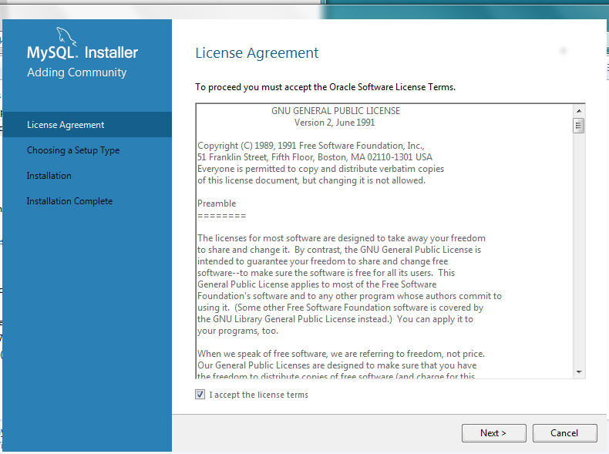

You must check the "I accept the license terms" and click Next to continue.

Step 2 - Choosing a Setup Type. Select the **Server Only** option.

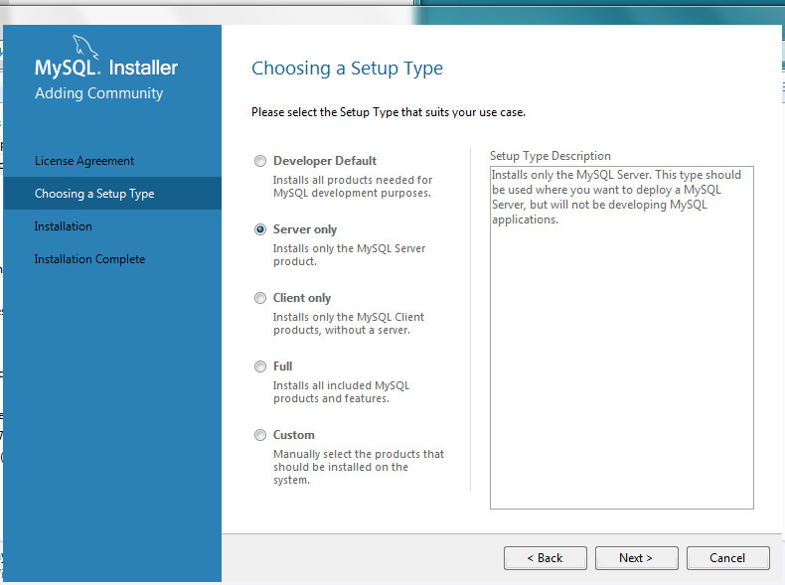

Click Next.

Step 3 - Installation

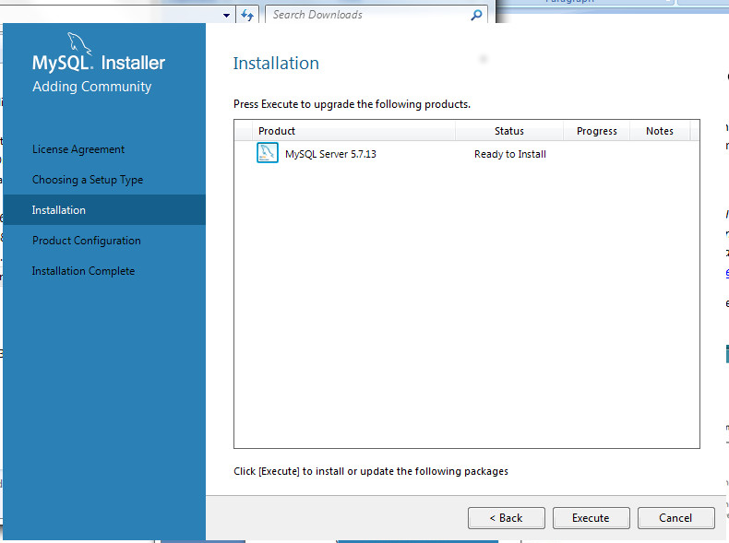

Click Execute.

Step 4 - Installation Complete. You can click on the Show Details button to track the progress of the install. When the install is complete, a green check mark will appear before the MySQL 5.7.13 Server entry.

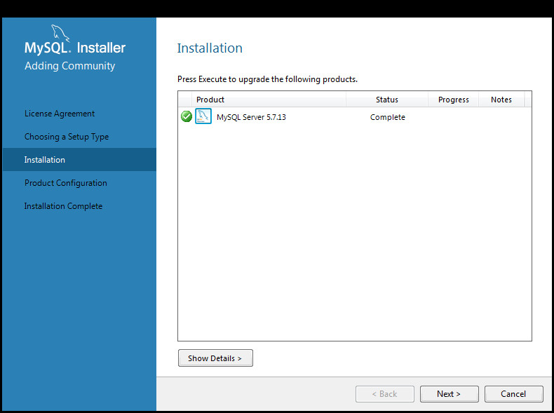

Click Next.

Step 5 - Product Configuration.

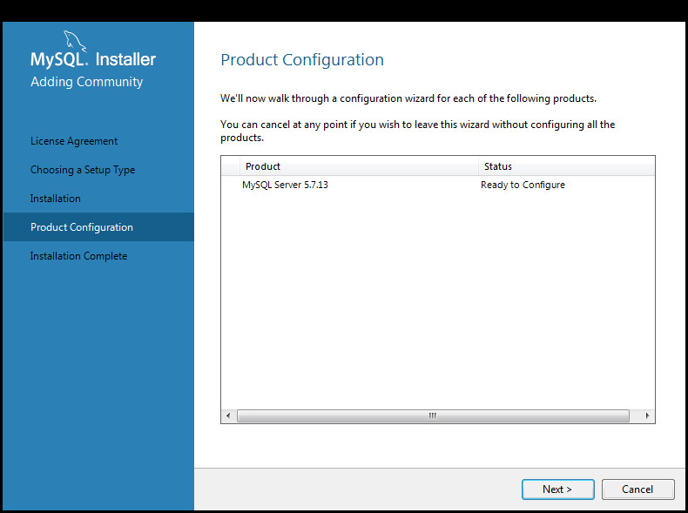

Click Next.

Step 6 - Type and Networking. For our purposes, we'll specify this install as a Development Machine and leave all of the defaults selected in place.

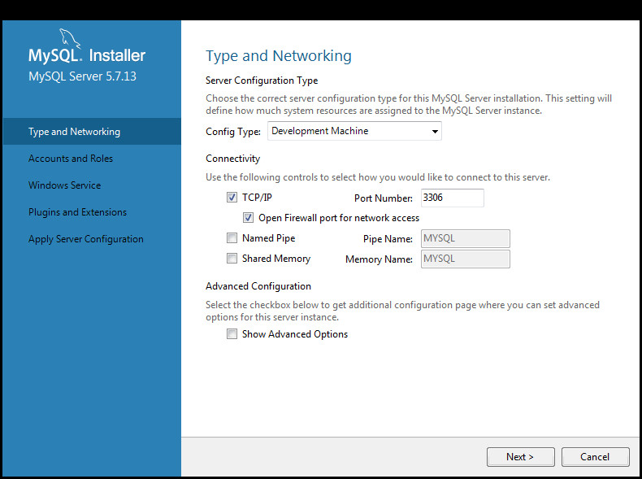

Click Next.

Step 7 - Accounts and Roles. Create, confirm (and remember) the MySQL root password you enter on this screen.

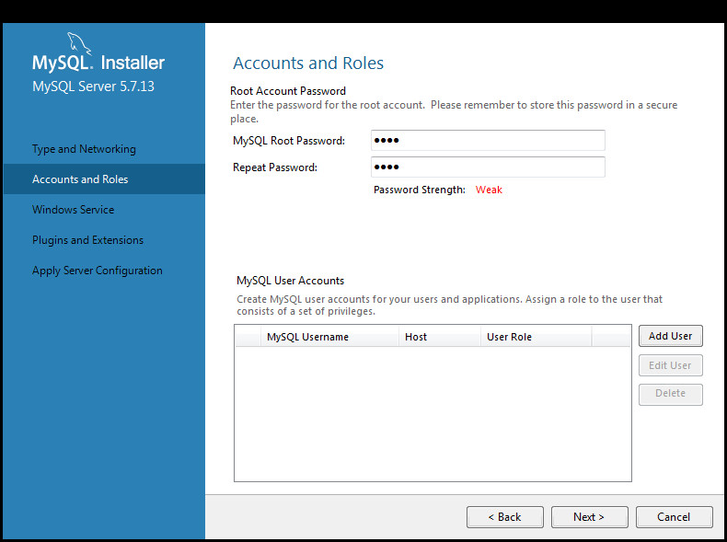

Click Next.

Step 8 - Windows Service. Leave all the defaults here in tact so that a Windows service will be installed and started at boot time for MySQL.

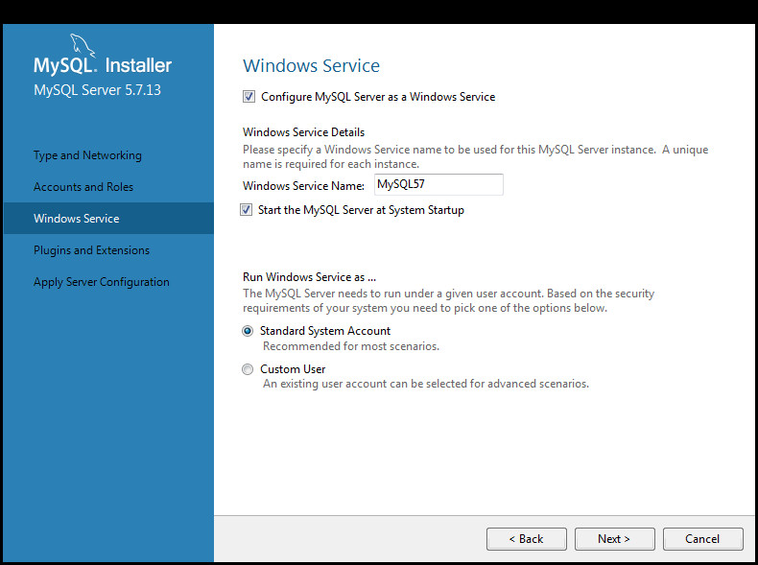

Click Next.

Step 9 - Plugins and Extensions. Make no changes to this screen.

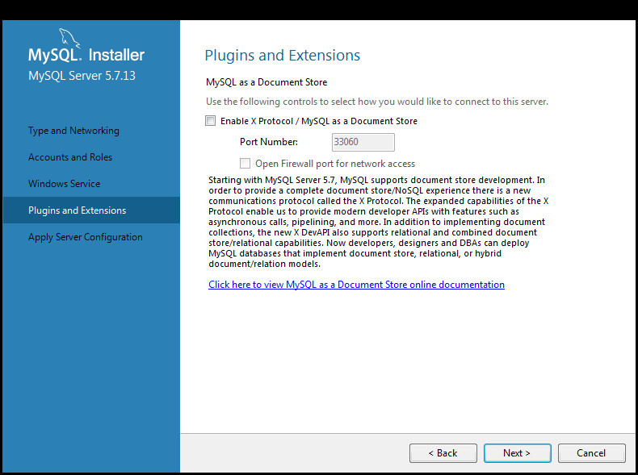

Click Next.

Step 10 - Apply Server Configuration.

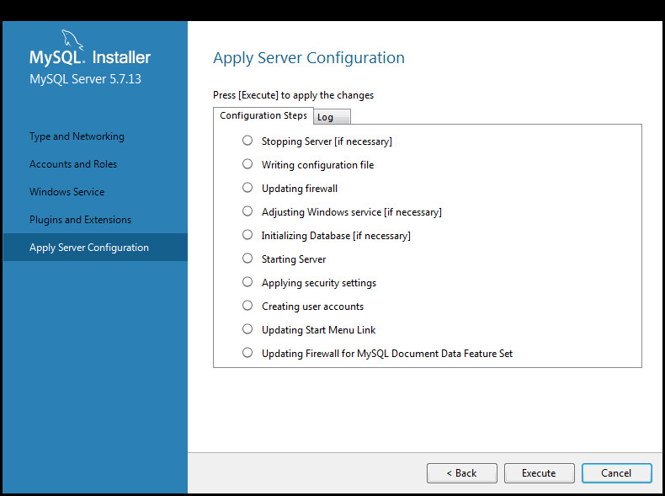

Click Execute.

Step 11 - Apply Server Configuration complete. When the Server Configuration is finished, you'll see green check marks in front of all the Configuration Steps.

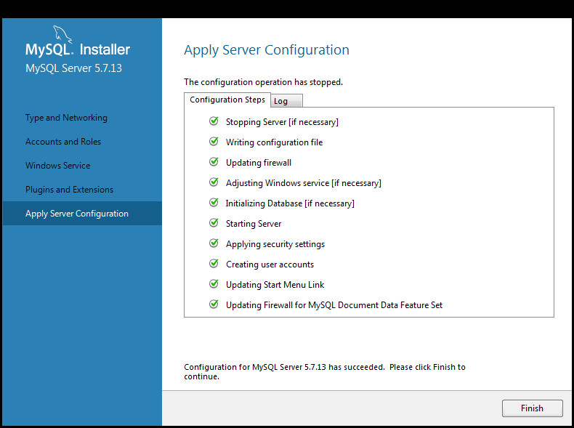

Click Finish.

Step 12 - Product Configuration.

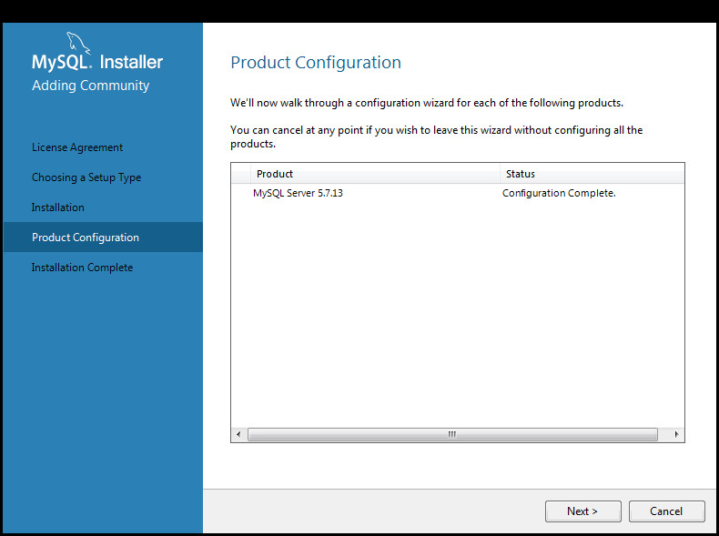

Click Next.

Step 12 - Installation Complete.

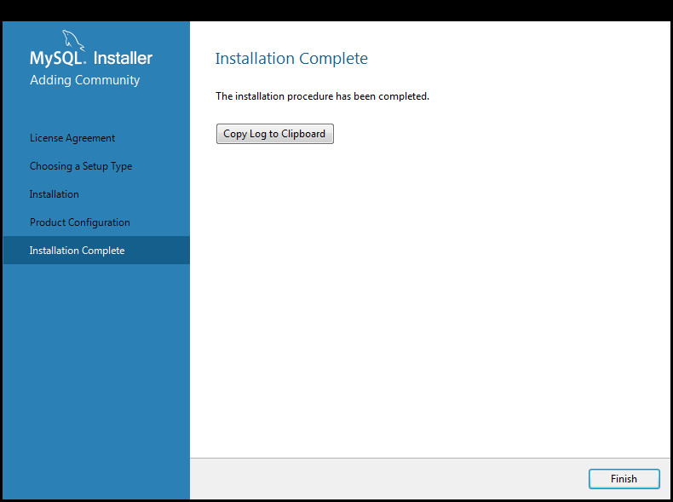

Click Finish.

**Post-Install: Configuring MySQL for Advanced Management Console**

1. A large portion of the MySQL installation should be located in the C:\ProgramData\MySQL\MySQL Server 5.7\ directory. Within that directory, edit the my.ini configuration file to support large BLOB entries by appending the following entries at the end of the[mysqld] section:

max_allowed_packet=100M

innodb_log_file_size=768M

2. Once this change has been made, you can either restart the MySQL57 Services via the Services Application (started by running services.msc from a CMD terminal *as Administrator*) or reboot.

3. As a convenience, add MySQL executables to the PATH.

Control Panel -> System -> Advanced System Settings -> Environment Variables

Select Path, then Edit the Variable Value text field:

Append

;C:\Program Files\MySQL\MySQL Server 5.7\bin\

onto the end of PATH Variable.

4. Create amc2 user. This is specific to MySQL and is not another Windows user.

>**mysql -u root -p**

Enter password: **\*\*\*\***

Welcome to the MySQL monitor. Commands end with ; or \g.

Your MySQL connection id is 4

Server version: 5.7.13-log MySQL Community Server (GPL)

Copyright (c) 2000, 2016, Oracle and/or its affiliates. All rights reserved.

Oracle is a registered trademark of Oracle Corporation and/or its

affiliates. Other names may be trademarks of their respective

owners.

Type 'help;' or '\h' for help. Type '\c' to clear the current input statement.

mysql>**create user 'amc2' identified by 'amc2';**

Query OK, 0 rows affected (0.00 sec)

Create the database and grant all access to the amc2 user

mysql>**create database amc2;**

Query OK, 1 row affected (0.00 sec)

mysql>**grant all on amc2.* to 'amc2';**

Query OK, 0 rows affected (0.00 sec)

mysql>**exit**

Bye**Install the Latest Java 8 Security Baseline Java Development Kit**

### A JDK, (not a JRE) is required for WebLogic.

### As of this document’s creation, the latest security baseline for Java 8 is JDK 8 update 161/162.

### IMPORTANT: With this revision of the document, the latest supported version of Fusion Middleware (WebLogic) is 12.2.1.3. There is a bug with 12.2.1.3 which fails to create an important configuration file called demoIdentity.jks (See My Oracle Support Doc ID 2357811.1 - FMW/WLS New Configuration with Latest JDK Failing to Start - ConfigException: Identity key store file not found: DemoIdentity.jks). There is a workaround, however, it is preferable (and easier) instead to install a version of Java earlier than Java 8u161/162 (i.e. Java 8u151/152) for WebLogic installation purposes. Once WebLogic installation is complete, the jdk8/ directory (referenced directly below) can be replaced with a more recent version.

### As an optional but recommended step, copy the contents of the installed JDK over to a local directory named jdk8. By using a local copy of the JDK and placing it in a generic directory name like jdk8, we will be able to replace WebLogic's JDK with a later Java 8 update at any time with no impact on the WebLogic install.

### In this document we will set the JAVA_HOME variable to C:\Oracle\jdk8 and copy the JDK contents to this directory.

### Install WebLogic 12.2.1.3

### As of the release of Java Advanced Management Console 2.9, Oracle WebLogic 12.2.1.3 is the latest version and is supported but may not be listed in the documentation. *The installation steps and screenshots that follow demonstrate how to install WebLogic 12.2.1.3, Previous versions of WebLogic 12c are also supported for Java AMC 2.9. Installation of those versions should be quite similar.*

### Step 1 - WebLogic Install. Download the Oracle WebLogic Server 12.2.1.3 Generic installer from the Oracle website. The downloaded file should be named: fmw_12.2.1.3.0_wls_Disk1_1of1.zip

### Extracting the contents of the aforementioned zip file, there should be one file present: fmw_12.2.1.3.0_wls.jar

Begin the installation process by executing the following commands **as Administrator**. Your path may vary depending on installation location and JDK version installed.

>set JAVA_HOME=C:\Oracle\jdk8

>set PATH=C:\Oracle\jdk8\bin;%PATH%

>java -jar fmw_12.2.1.3.0_wls.jar

This will ultimately launch the universal installer as shown below.  
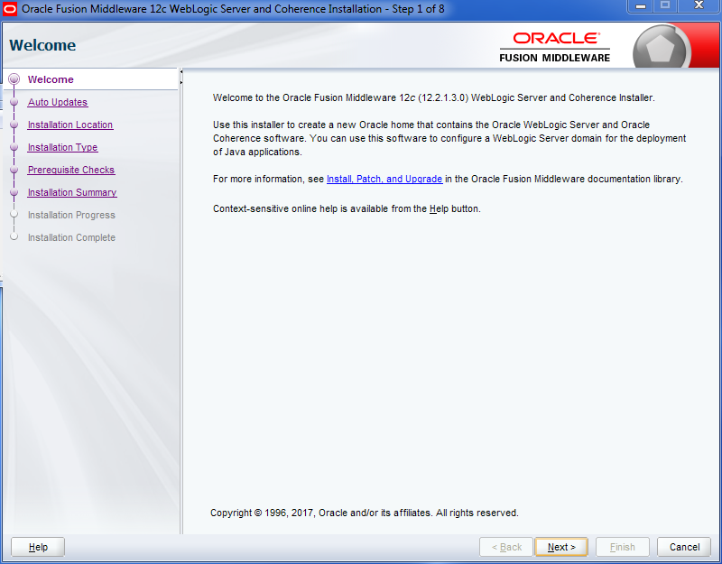

Click the Next Button

Step 2 - Auto Updates Screen. Leave screen as is and Skip Auto Updates.

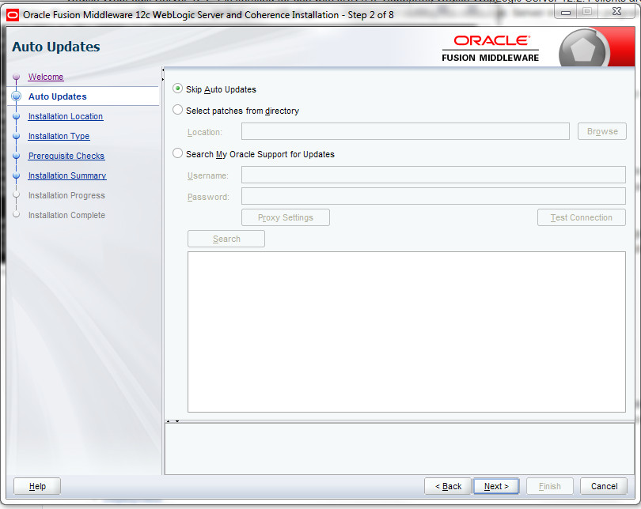

Click Next.

Step 3- WebLogic Install. Choose the installation directory. We'll stay with the default:

C:\Oracle\Middleware\Oracle_Home

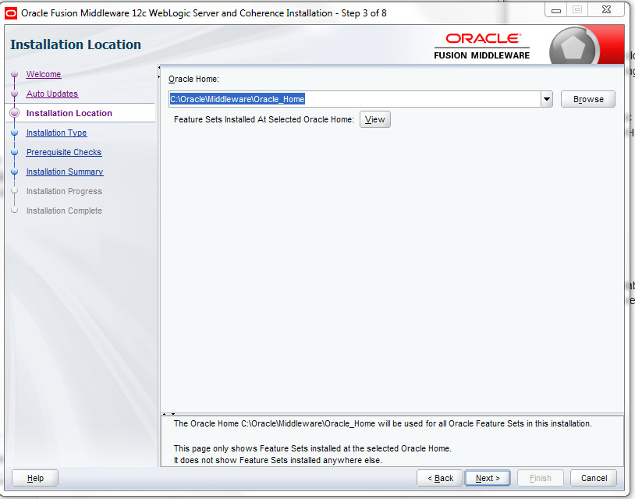  
  
Click the Next button.

Step 4 - WebLogic Install. The Installation Type should have only WebLogic server selected.

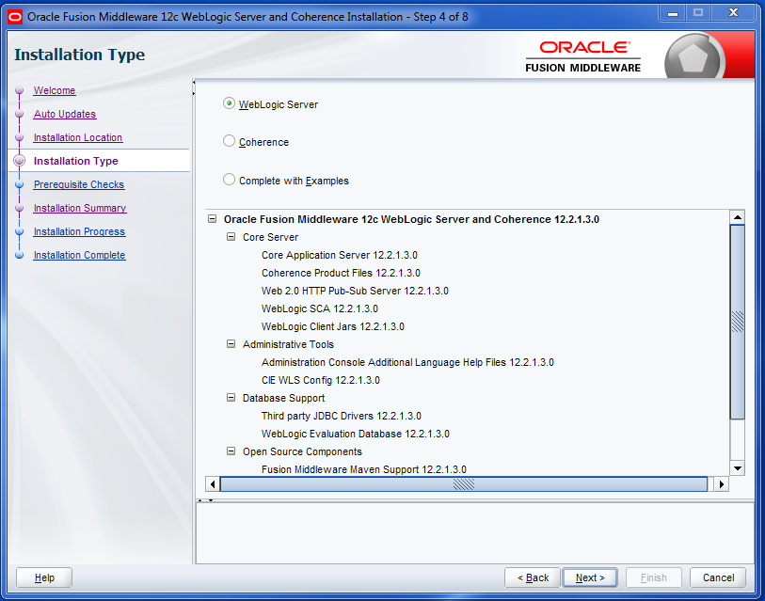

Click the Next button.

Step 5 - WebLogic Install. Prerequisite Checks: in order to continue, your JAVA_HOME variable should be set to a valid JDK, not a JRE.

If you're using a very recent version of Java 8, you might see a warning stating that at the time of the release of WebLogic 12.2.1.3, your version wasn't certified (because it didn't exist at the time of the release). You can ignore this warning.

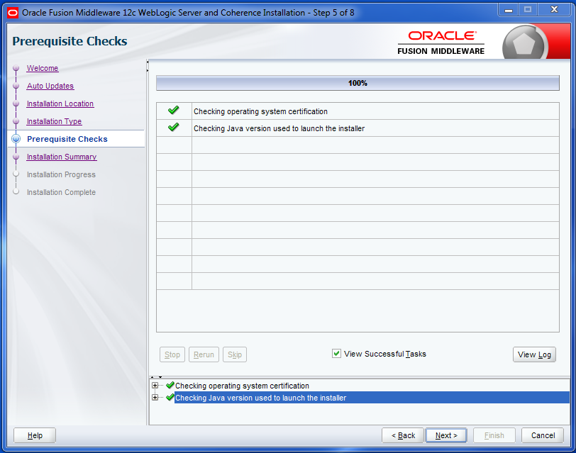

Click the Next button.

Step 6 - WebLogic Install. Installation Summary screen.

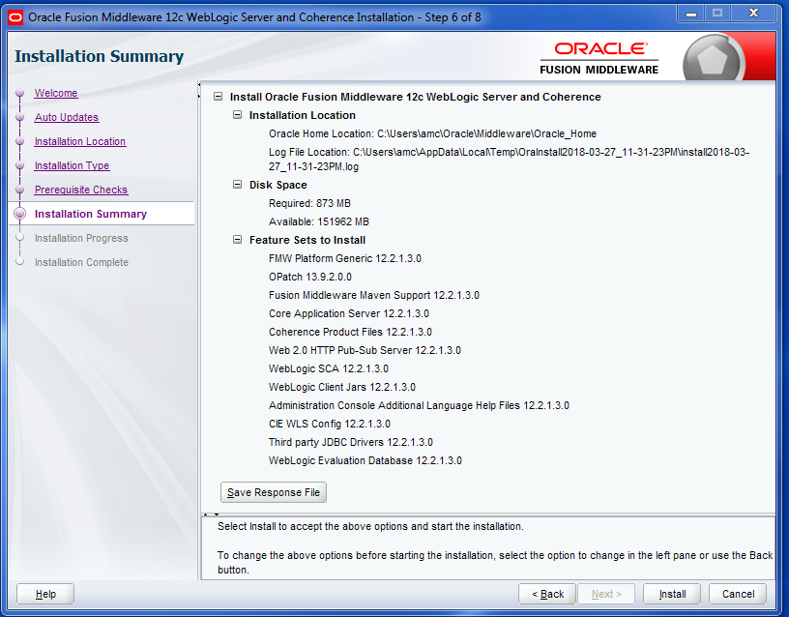

Click the Install button to begin installation.

Step 7 - WebLogic Install. Installation Progress screen. As the install progresses, green check marks will appear before completed items.

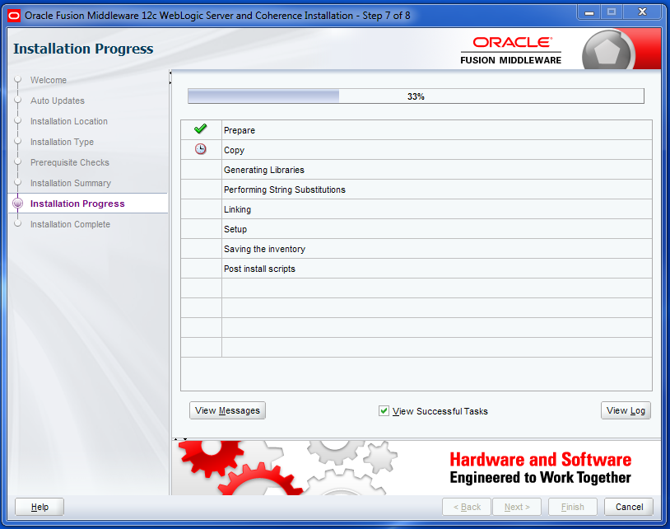

When all components have been successfully installed, the Next button at the bottom of the window will no longer be grayed out.

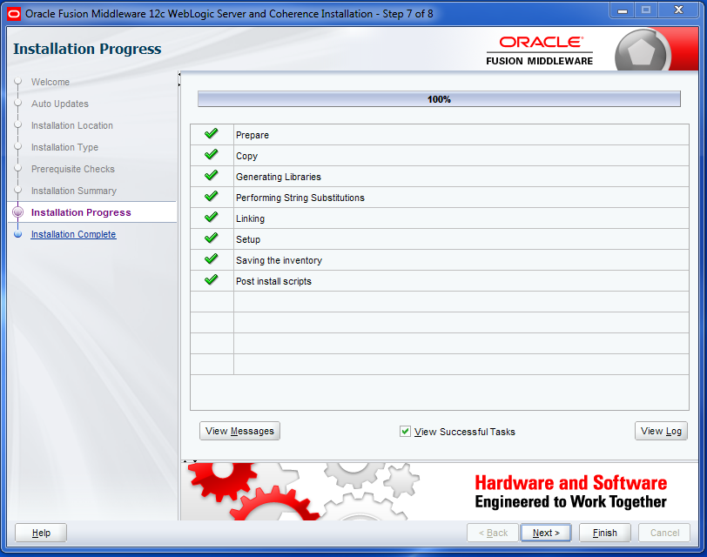

Click the Next button

Step 8 - WebLogic Install. Installation Compete screen.

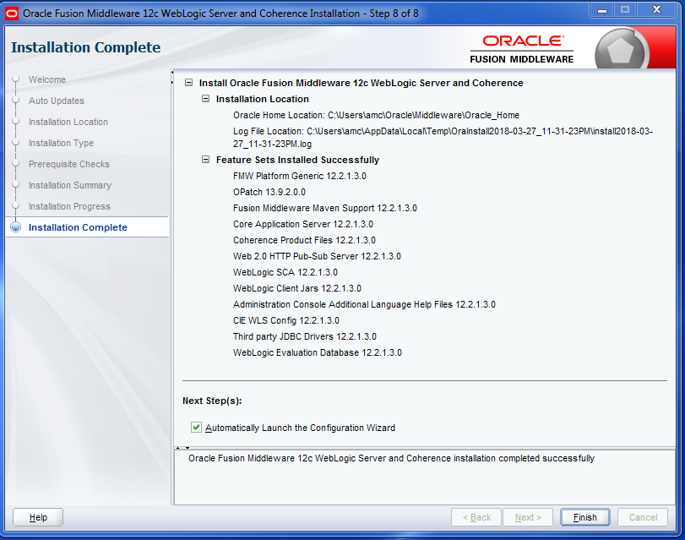

Click Finish.

**Fusion Middleware Configuration Wizard**

Once the WebLogic Installer completes, the Fusion Middleware Configuration Wizard will automatically start.

Step 1 - Fusion Middleware Configuration Wizard.Default setting should be to create a new domain, we'll leave the default settings as is. Note the file system location of the newly created domain.

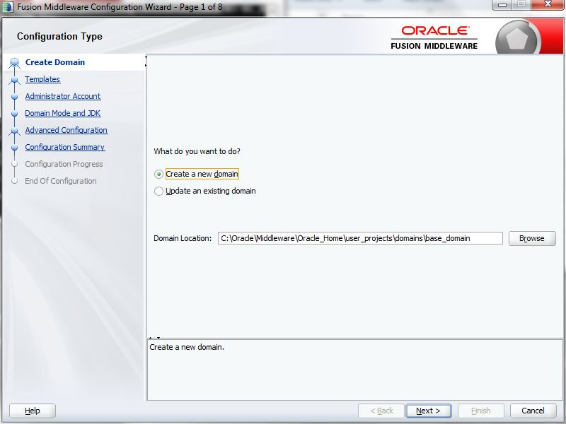

Click Next.

Step 2 - Fusion Middleware Configuration Wizard. We do not require any special templates for this install. By default the “Basic WebLogic Server Domain” templates are selected. Click on the “Include all selected templates” checkbox.

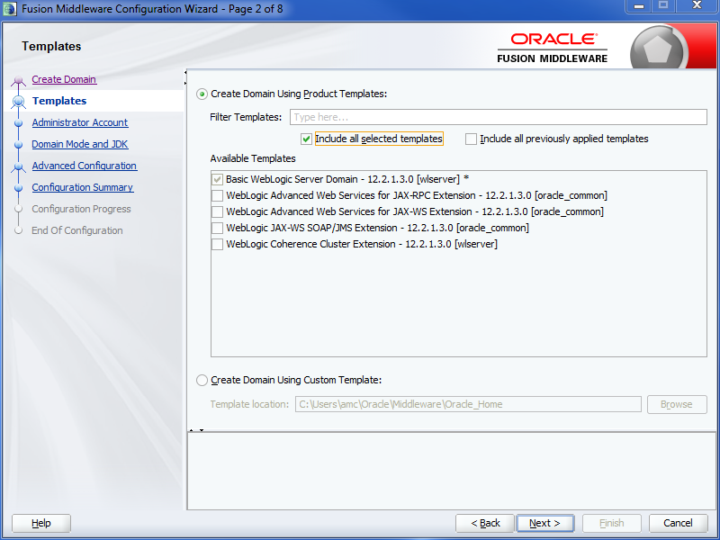

Click Next.

Step 3 - Fusion Middleware Configuration Wizard. Type in (and remember!) a WebLogic administrator password.

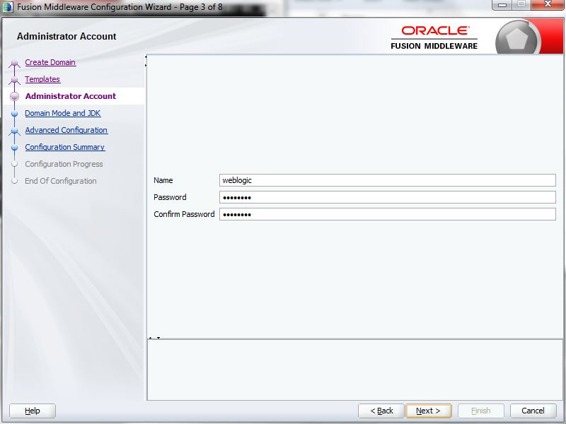

Click Next.

Step 4 - Fusion Middleware Configuration Wizard. For a prototype installation, "Development" Domain Mode is appropriate.

Because we installed a local copy of the JDK and set the JAVA_HOME variable prior to installation, the JDK location specified in the JDK section should point to the local copy, in our case C:\Oracle\jdk8.

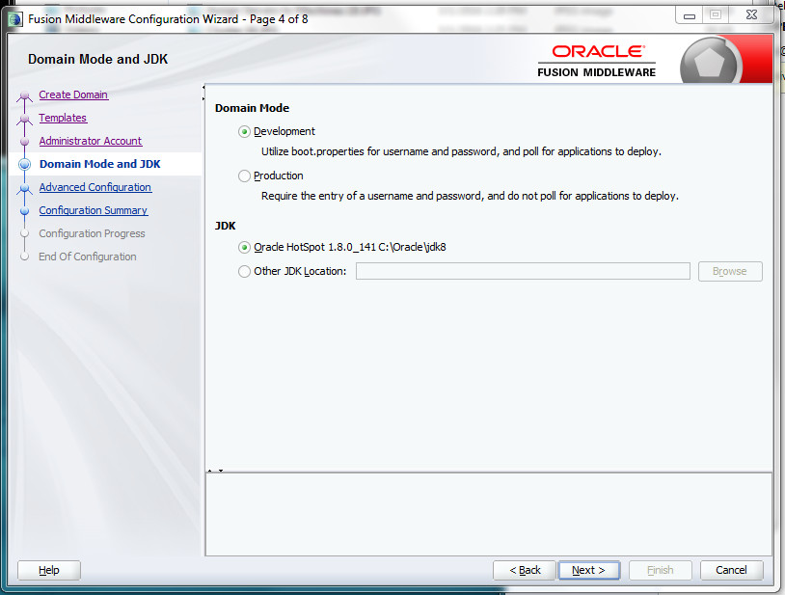

Click Next.

Step 5 - Fusion Middleware Configuration Wizard. For this screen, **check all three checkboxes**, so we can better understand the installation and fine tune our configuration.

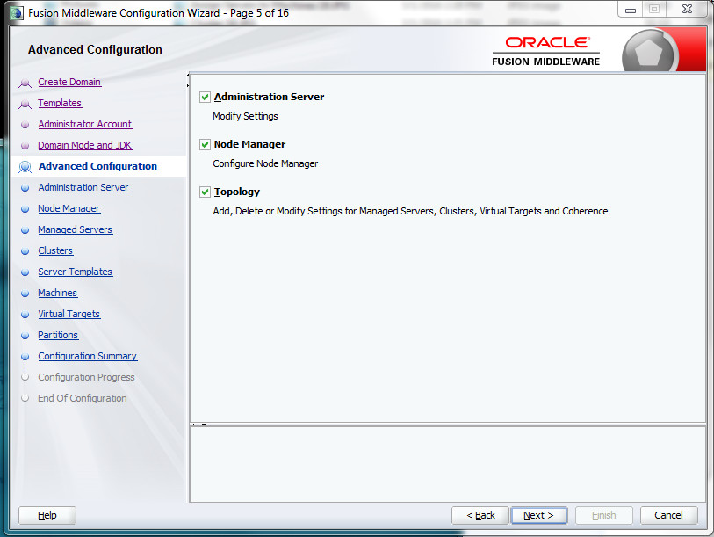

Click Next.

Step 6 - Fusion Middleware Configuration Wizard. Because we chose to configure the Administration Server in the last step, we can further refine the AdminServer's Listen Address. It is important to understand at which IP + TCP port the AdminServer will run.

WebLogic will by default pickup all available interfaces (which can be determined by issuing the “ipconfig /all” command). This can be very problematic on Windows with its default “Turedo Tunneling Pseudo-Interface” which uses IPv6. When Windows is not well configured for IPv6, WebLogic performance will suffer because the java process will use the unconfigured IPv6 first, before it times out, and then IPv4.

**In short, it is a good idea to explicitly define the IPv4 address you want to use, instead of**

**giving all interfaces to the WebLogic java processes.**

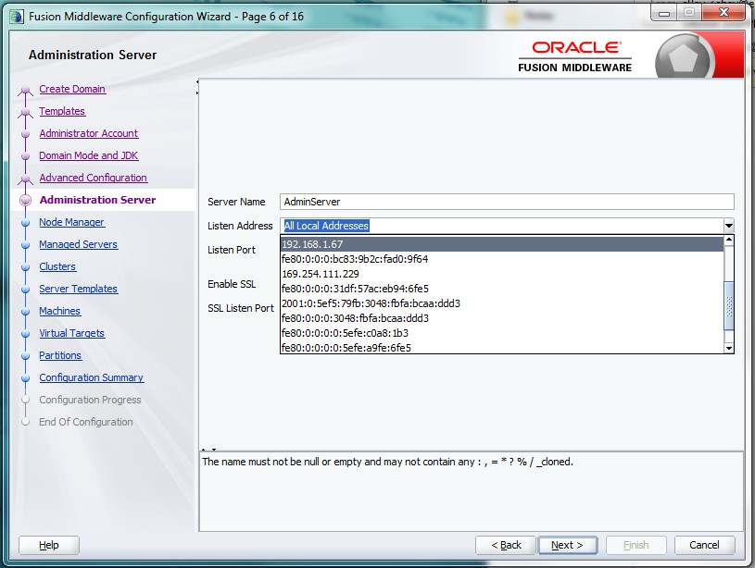

Once you select the appropriate IPv4 address from the "Listen Address" pull-down menu, leave the Listen Port at 7001 and the SSL information blank.

After Installation, we'll use the selected IP Address above to open the WebLogic Admin Console, for example, http://192.168.1.67:7001/console

Click Next.

Step 7 - Fusion Middleware Configuration Wizard. Configure the “Per Domain Nodemanager” and define the (Embedded LDAP)NodeManager credentials.

On Production Systems the NodeManager is started as a System Service

and is used to start and stop the AdminServer, clusters and Managed Servers.

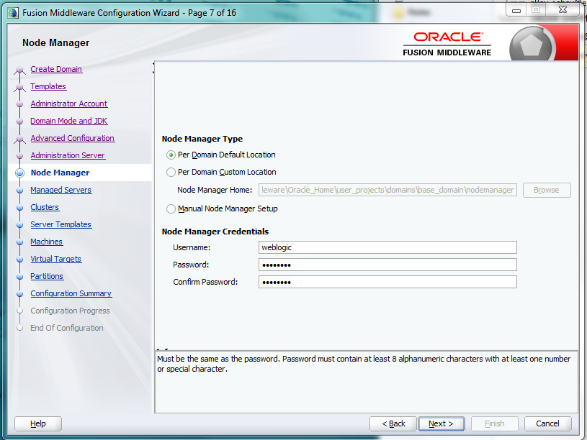

Once a username and password have been entered and confirmed (and remembered!), click Next.

Step 8 - Fusion Middleware Configuration Wizard. On this screen click on the "+ Add" button to add a Managed Server. **Rename the Managed Server to "AMC-Server"** and click on the **Listen Address pull-down menu to select the IPv4 Address chosen in Step 6**. **Change the Listen port to 8007** (so as not to interfere with the AdminConsole), **click on the Enable SSL checkbox** and **change the SSL Listen Port to 8008.**

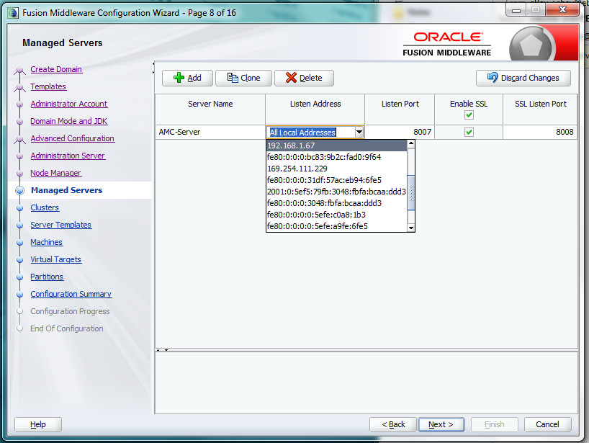

Click Next.

Step 9 - Fusion Middleware Configuration Wizard. We won't configure any clusters, so you can skip this screen.

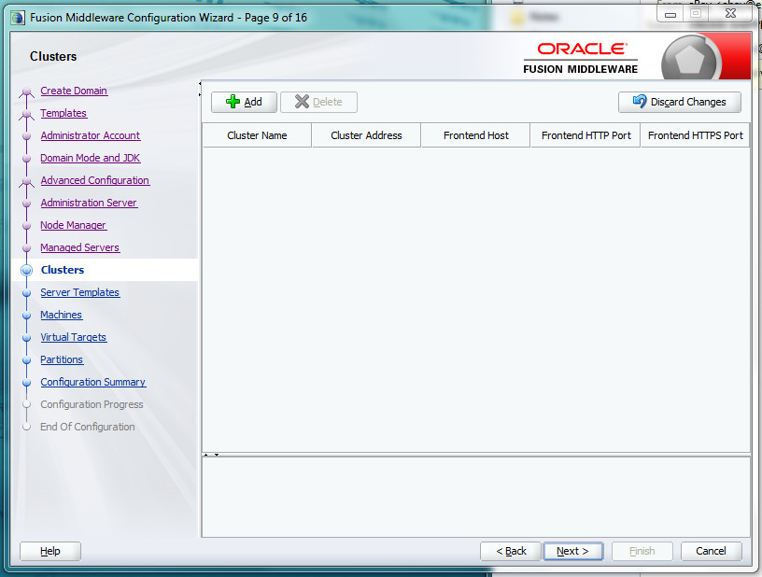

Click Next.

Step 10 – Server Templates. We won't configure any server templates, so you can skip this screen.

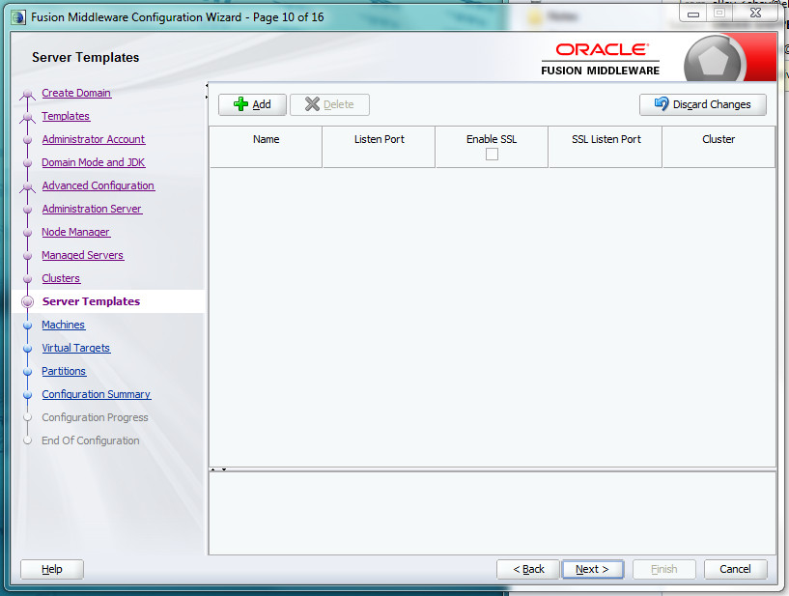

Click Next.

Step 11 - Fusion Middleware Configuration Wizard. Click on the “Add” button and **name the Machine Name to "AMC-Machine"** and click on the **Listen Address pull-down menu to select the IPv4 Address chosen in Step 6**. **Leave the Node Manager Listen port at 5556.**

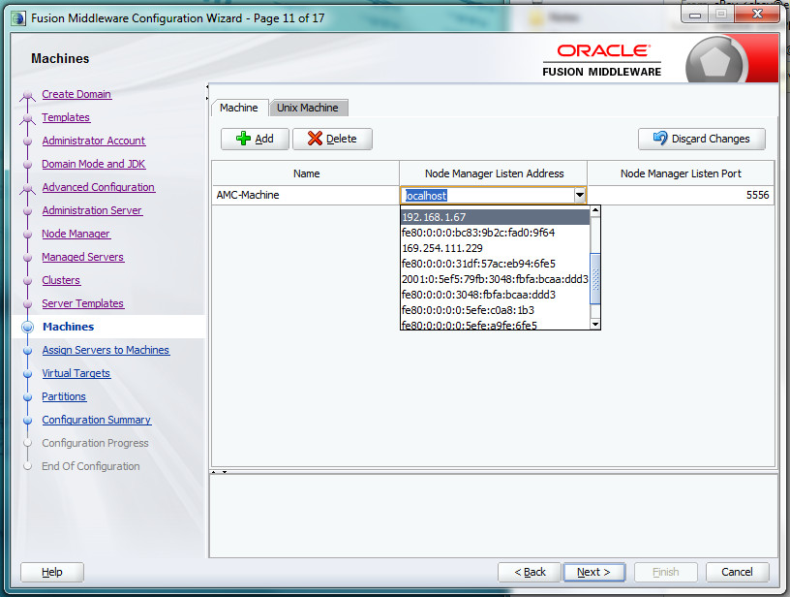

Click Next.

Step 12 - Fusion Middleware Configuration Wizard. Assign all WebLogic Servers (java processes) that you want to manage with the NodeManager. In this case **we include AMC-Server and AdminServer under AMC-Machine.**

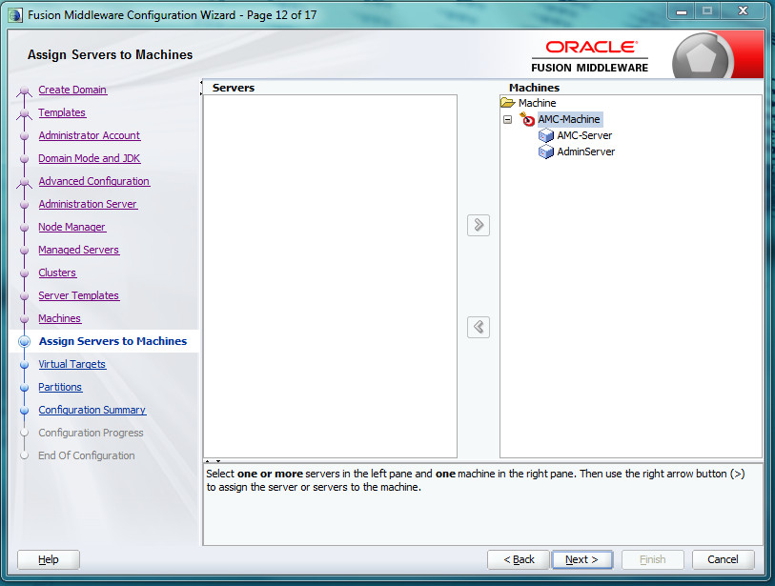

Click Next.

Step 13 – Virtual Targets. We won't configure any virtual targets, so you can skip this screen.

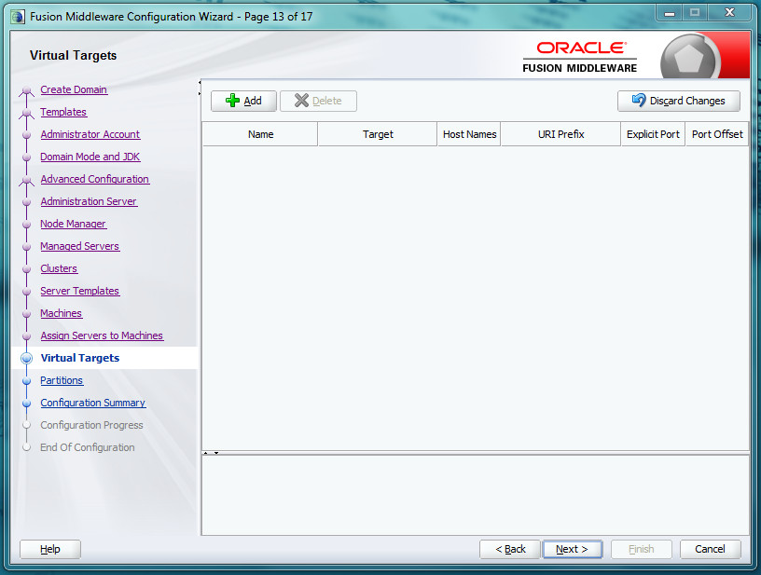

Click Next.

Step 14 – Partitions. We won't configure any partitions, so you can skip this screen.

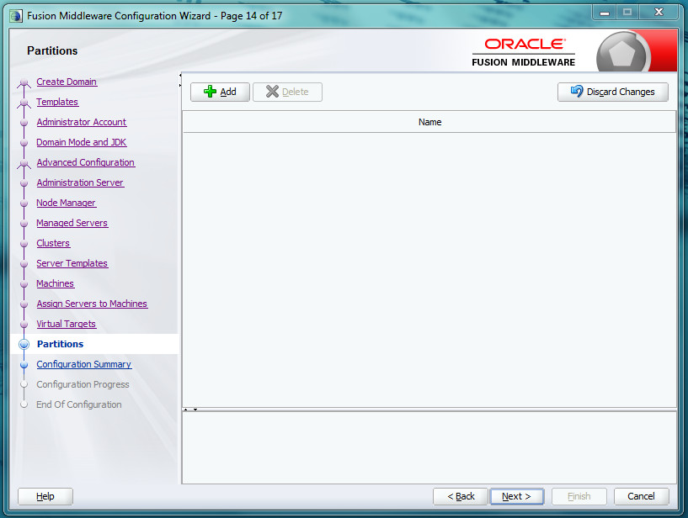

Click Next.

Step 15 - Fusion Middleware Configuration Wizard. Configuration Summary.

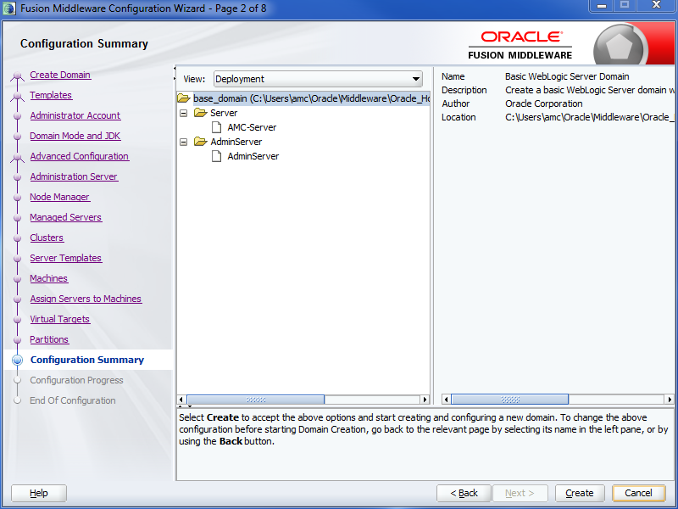

Click Create.

Step 16 - Fusion Middleware Configuration Wizard. Configuration Progress. When complete, the Next button will no longer be grayed out.

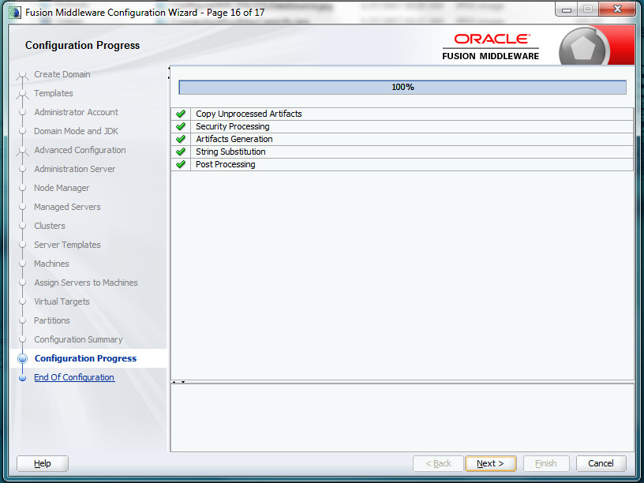

Click Next.

Step 17 - Fusion Middleware Configuration Wizard. Configuration Success.

Remember the domain location and Admin Server URL for future reference.

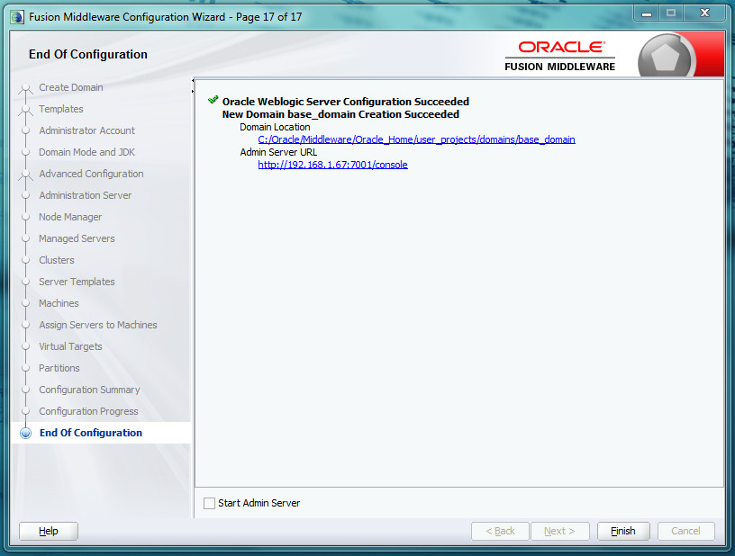

Click Finish.

**Install an identity certificate (optional for Java AMC Evaluation)**

WebLogic will create and utilize a self-signed identity certificate which may not be adequate for certain browser deployments. In this situation, it might be necessary to configure WebLogic to use a custom keystore containing an identity certificate from a trusted authority.

Assumption: The custom keystore containing the necessary certificate(s) is provided as a file in ***JKS*** format. For a little more information on installing trusted certificates into a Java keystore, check out:

https://blogs.oracle.com/jtc/entry/installing_trusted_certificates_into_a

1. If you don't know it already, determine the *alias name* of your trusted certificate. You can use the keytool utility to find out. Here's an example invocation assuming the certificate keystore can be found in a file named identity.jks:

>C:\Oracle\jdk8\bin\keytool.exe -keystore identity.jks -list -v

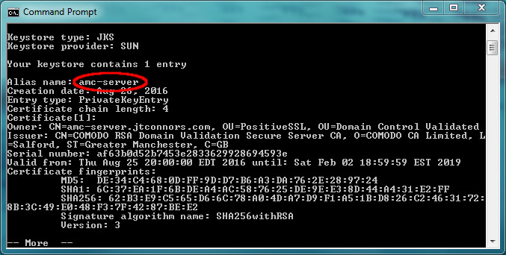

2. It is important to validate your identity keystore certificate chain. WebLogic can be finicky when it comes to insuring that the provided private key along with the root CA and any intermediate certificates (referred to as a certificate chain) are valid and stored in the correct order.

WebLogic contains a ValidateCertChain program as part of the distribution which can be used to validate the keystore. It can be run like this:

>java -cp C:\Oracle\Middleware\Oracle_Home\wlserver\server\lib\weblogic.jar utils.ValidateCertChain -jks amc-server identity.jks

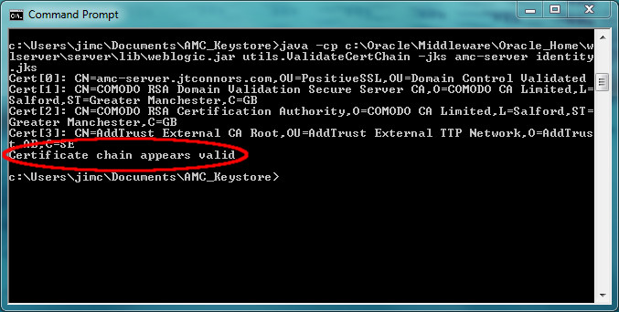

3. If it isn't running already, start the WebLogic server. It can be started manually with the following commands:

> C:\Oracle\Middleware\Oracle_Home\user_projects\domains\base_domain\bin\startWebLogic.cmd

4. Log into the WebLogic Console:

http://*<IP Address>:*7001/console

Username: *<WebLogic admin user>*

Password: *<WebLogic admin password>*

5. Instruct WebLogic use a different Identity KeyStore.

a. Within the WebLogic console, from the domain structure block to the left, go to Environment and select Servers

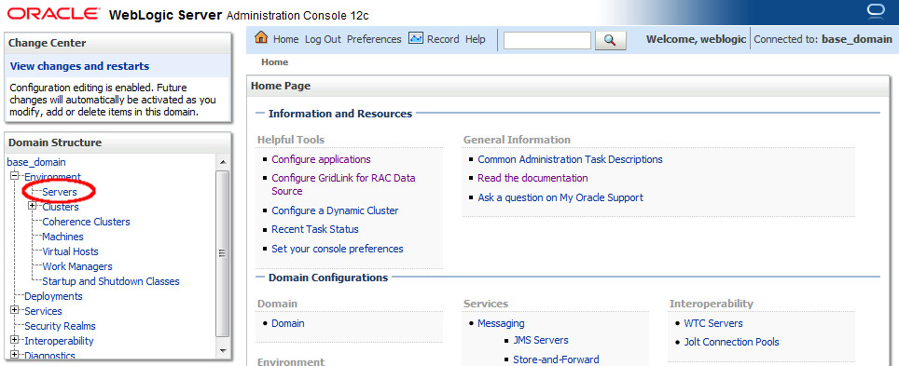

b. Click on AMC-Server link under Servers table

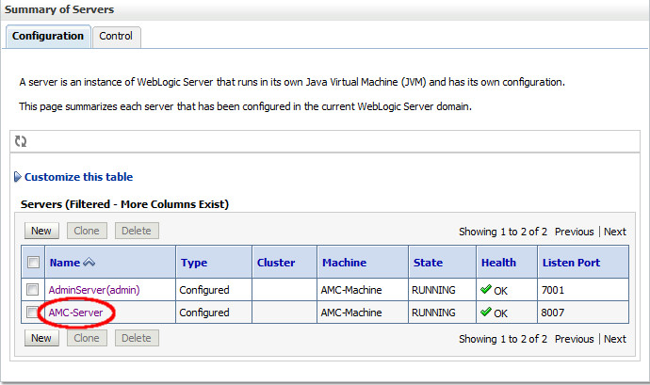

c. Click on Keystores tab

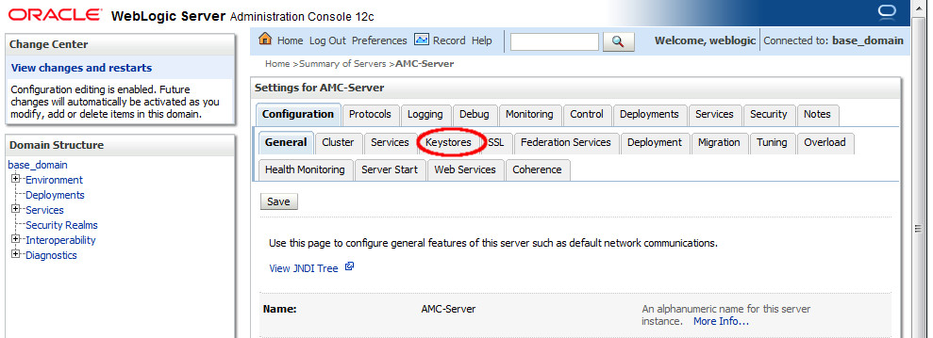

d. For the "Keystores:" entry, click "Change" button

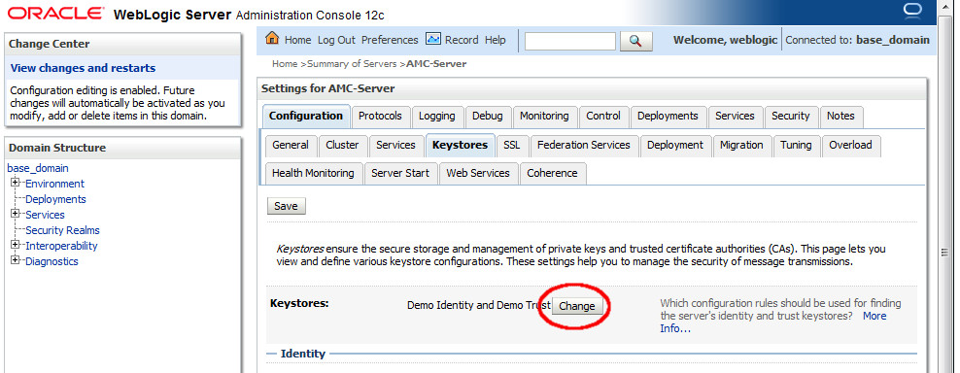

e. Select Custom Identity and Java Standard Trust

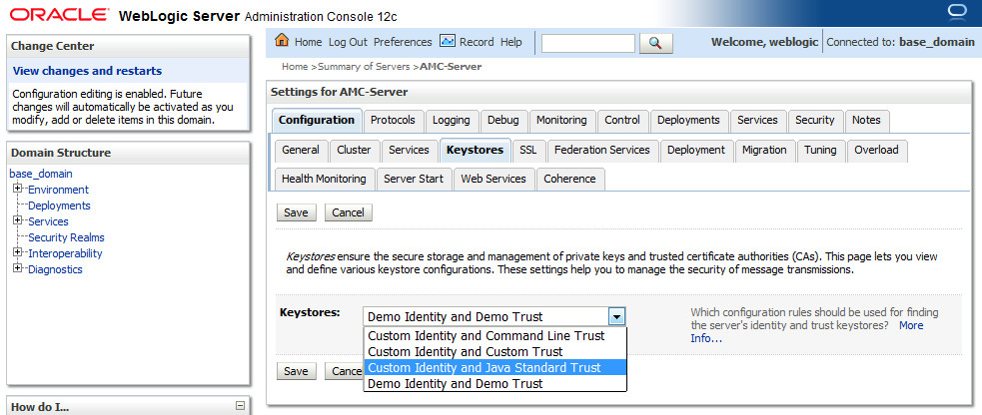

f. Click Save

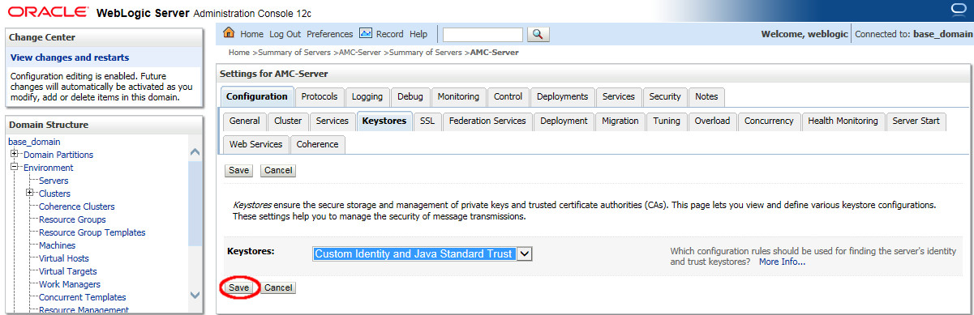

6. Specify Custom Identity Keystore information

1. Under the same "Keystores" tab as in the previous step, Fill in the location of your custom identity keystore.
2. Custom Identity Keystore Type is: jks
3. Fill in Custom Identity Keystore Passphrase.
4. Fill in the Confirm Custom Identity Keystore Passphrase textfield with the same passphrase entered in the previous step.
5. Java Standard Trust Keystore should point to the JDK's cacerts file
6. Example: C:\Users\amc\jdk8\jre\lib\security\cacerts
7. Java Standard Trust Keystore Type should be: jks
8. Unless it's been changed, the Java Standard Trust Keystore Passphrase should be *changeit*
9. Fill in the Confirm Java Standard Trust Keystore Passphrase text field with the same passphrase entered in the previous step.
10. Click Save

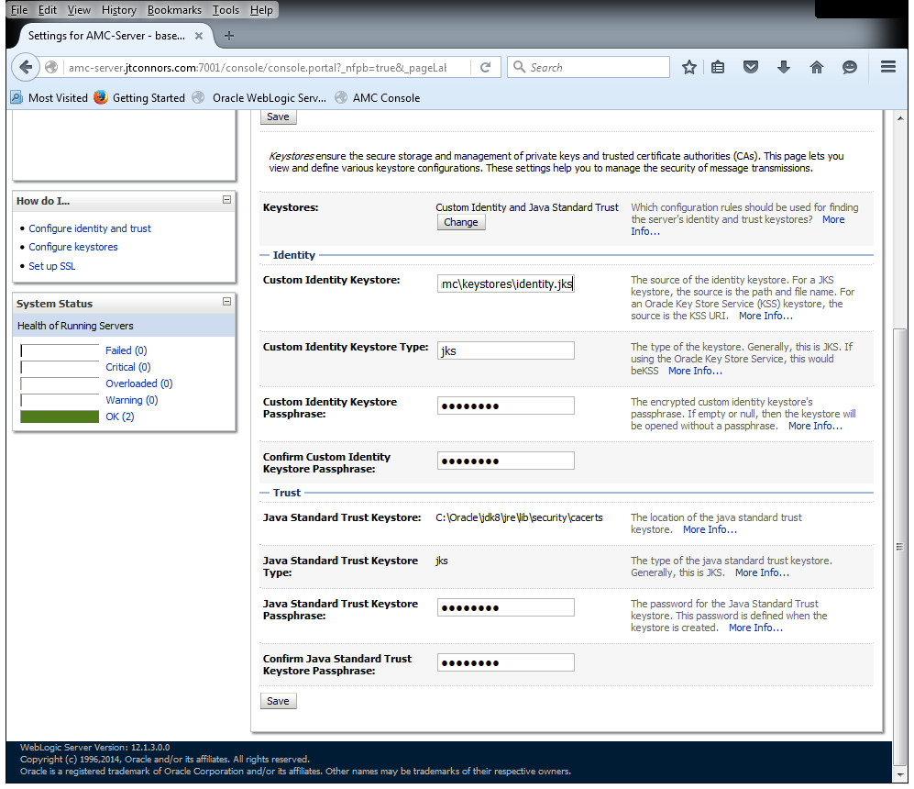

7. Configure SSL

a. Within the WebLogic console, from the domain structure block to the left, go to Environment and select Servers

b. Click on AMC-Server link under Servers table

c. Click on the SSL tab

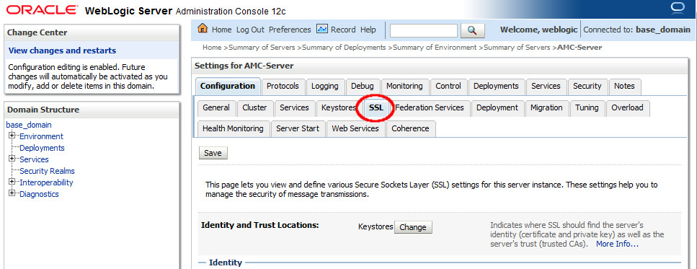

d. Enter the Private Key Alias. This was determined in Step 1.

Example: amc-server

e. Enter your Private Key Passphrase.

f. Fill in the Confirm Private Key Passphrase text field with the same passphrase entered in the previous step.

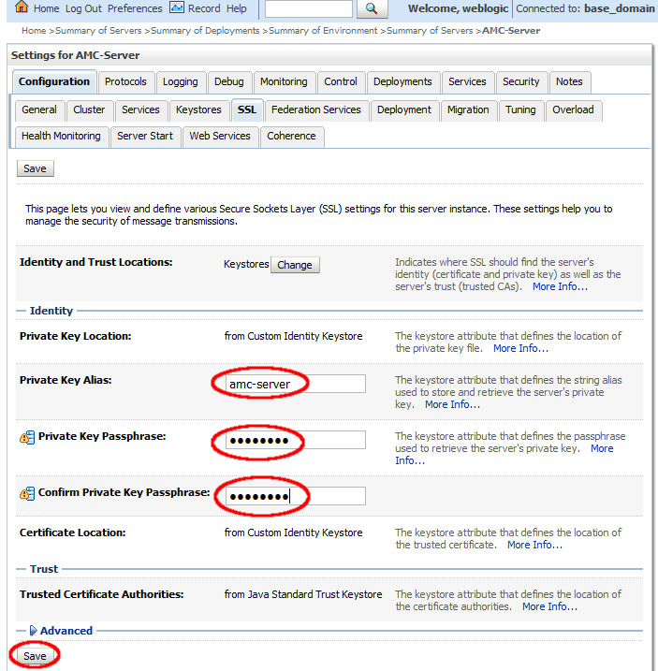

g. Click Save

**Additional WebLogic Configuration for Java Advanced Management Console**

**Run the Java Version of NodeManager**

WebLogic can be configured to run the NodeManager process natively or in Java. For Java AMC, we want to run the Java version of NodeManager. In order to effect this change, we need to modify nodemanager.properties file.

This file is located in the %DOMAIN_HOME%\nodemanager\ directory. In our example, that would be

c:\Oracle\Middleware\Oracle_Home\user_projects\domains\base_domain\nodemanager\nodemanager.properties

Edit the file and change the NativeVersionEnabled flag to false.

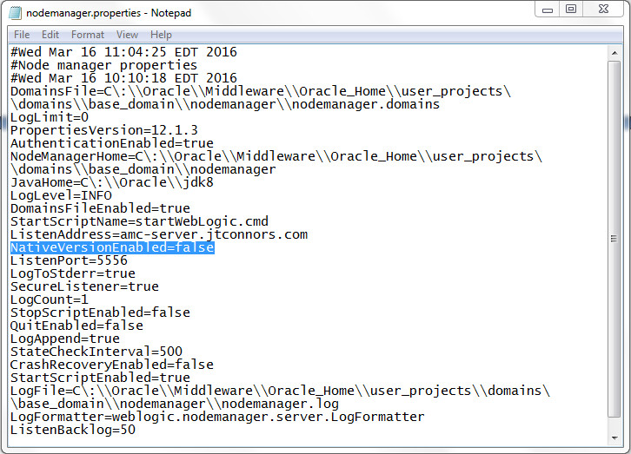

**Increase the JTA Timeout Parameter**

Errors in the WebLogic Server may occur if the JTA transaction timeout is not set to a long enough value for database access.

(<http://docs.oracle.com/javacomponents/advanced-management-console-2/install-guide/wlssetup.htm#A1147784>)

A. If it isn't running already, start the WebLogic server. It can be started manually with the following commands:

>C:\Oracle\Middleware\Oracle_Home\user_projects\domains\base_domain\bin\startWebLogic.cmd

B. Log into the WebLogic Console:

http://*<IP Address>:*7001/console

Username: *<WebLogic admin user>*

Password: *<WebLogic admin password>*

C. From the Domain Structure block in the left panel, navigate to Services and select JTA from services.

D. Select the Configurations tab and then click the JTA sub tab.

E. On the Java Transaction API (JTA) page, enter the Timeout Seconds value as 300.

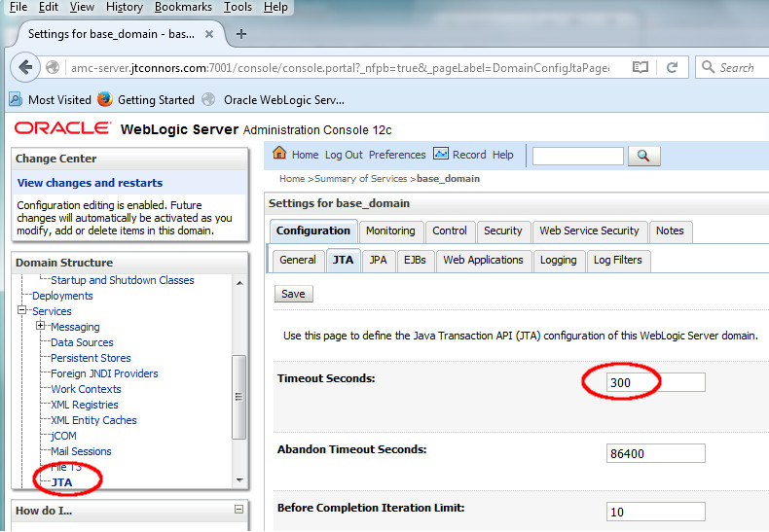

F. Click Save

**Install Windows Services for WebLogic, Node Manager, and the Java AMC Server Application**

The WebLogic component of Java Advanced Management Console is comprised of three separate processes. In order to enable the proper and automatic start up sequence at boot time, these processes should be converted into Windows services. This guide provides two options to create these services:

1. Create the services using an automated script. This is the easier method and is described directly below.
2. Manually Create the WebLogic Services. This method goes into more detail and potentially offers more flexibility in the creation of the Windows services. These instructions can be found in the Appendix section under Manually Installing Windows Services for WebLogic, Node Manager and the Java AMC Application

The following steps will create three Windows services that will enable WebLogic, the WebLogic Node Manager and the Java AMC application to automatically start up at boot time.

1. Create and populate a scripts directory. One recommendation is to place scripts directly under the master directory where all WebLogic software would be housed. For example:

>mkdir C:\Oracle\scripts

>cd C:\Oracle\scripts

2. Place the three provided script files: svcsetup.cmd , makeAllScripts.bat and makeAllScripts.ps1 into the scripts directory created in the previous step. Assuming C:\Oracle\scripts is our scripts location, it should look as follows:

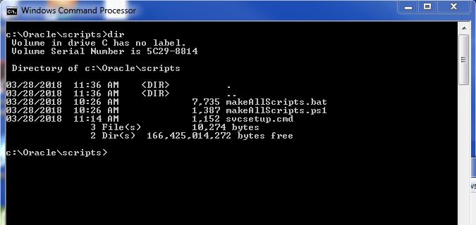

3. Examine and edit, if necessary, the svcsetup.cmd file in the scripts/ directory.

3a. Check to see if the AMC_HOME variable is set correctly. The WebLogic Middleware/ directory should reside directly under the directory specified by AMC_HOME. If your directory differs from the default value of AMC_HOME (C:\Oracle), it is important that you edit the AMC_HOME to match your installation directory.

REM

REM AMC_HOME must point to the AMC Master directory from which all WebLogic

REM software is installed.

REM

set AMC_HOME=C:\Oracle

3b. Following AMC_HOME, make sure the JAVA_HOME variable points to the location of your JDK.

REM

REM JAVA_HOME location is better off having a directory name like "jdk8" as

REM opposed to a specific version (like "jdk1.8.0_161), so that it can easily

REM be replaced with a newer update, keeping the generic "jdk8" name.

REM For organization's sake, it might make sense to have a jdk directly under

REM the AMC_HOME directory.

REM

set JAVA_HOME=%AMC_HOME%\jdk8

3c. Optional: Uncomment out the following JAVA_OPTIONS setting if you suspect IPv4/IPv6 networking conflicts. It might be best to leave this as is until suspicions of network irregularities arise.

REM

REM This option has been handy in the past where the WebLogic server had

REM multiple network interfaces with both IPv4 and Ipv6 stacks. In the case

REM where network irregularities take place, try uncommenting the

REM JAVA_OPTIONS line that follows.

REM

REM set JAVA_OPTIONS=-Djava.net.preferIPv4Stack=true

3d. The remainder of the svcsetup.cmd should be left as is unless some specific customization is required.

REM

REM These Variables are set relative to AMC_Home and in most cases should be

REM left alone

REM

set MW_HOME=%AMC_HOME%\Middleware\Oracle_Home

set WL_HOME=%MW_HOME%\wlserver

set DOMAIN_NAME=base_domain

set DOMAIN_HOME=%MW_HOME%\user_projects\domains\%DOMAIN_NAME%

set USERDOMAIN_HOME=%DOMAIN_HOME%

4. Run the makeAllScripts.bat command. It will prompt you to provide input for the following values:

* The Java Advanced Management Console *server instance name*. The default value is **AMC-Server**, and unless, during the WebLogic install you specified a different name, this should not be changed.
* The WebLogic admin *user name*. The default value is **weblogic**. If you followed the install instructions in this document, this value should not be changed either.
* The WebLogic admin *password*. The default value is **weblogic1**, which is likely different from the one you chose during the installation phase. Use the value you used (and hopefully remembered!) during the WebLogic install.
* The *hostname or IP address* of your WebLogic server.
* The port number of the WebLogic Administration Server. The default value is **7001**, and unless you specified something different during the WebLogic install, this should not be changed.

Here’s what a sample invocation of the script looks like. In this instance, the defaults were chosen for the AMC-Server, WebLogic admin user name and the WebLogic administration server port number values. The selected WebLogic password was changed to AMC2Demo, and the hostname of the WebLogic Server was set to an example fully qualified domain name. Yours will certainly be different.

C:\Oracle\scripts>makeAllScripts.bat

Checking file locations

1 file(s) copied.

Editing scripts in C:\Oracle\Middleware\Oracle_Home\wlserver\server\bin

Press any key to continue . . .

Found existing scripts directory: C:\Oracle\scripts.

Type a new server name or press enter to accept: [AMC-Server]

Type a new user name or press enter to accept: [weblogic]

Type a new password or press enter to accept: [weblogic1]**AMC2demo**

Enter the correct hostname or IP Address: **amc-server.jtconnors.com**

Type a new port number or press enter to accept: [7001] :

You've chosen to set

the Admin Server name to: AMC-Server

the username to: weblogic

the password to: AMC2demo

the hostname/IP to: amc-server.jtconnors.com

and the port to: 7001

are these values correct? [Y/n]Y

Created installAMCServerSvc.cmd in C:\Oracle\scripts

set MAX_CONNECT_RETRIES=

Created installWebLogicSvc.cmd in C:\Oracle\scripts

Created installNodeMgrSvc.cmd in C:\Oracle\scripts

Created uninstallAMCServerSvc.cmd in C:\Oracle\scripts

Created uninstallWebLogicSvc.cmd in C:\Oracle\scripts

Created uninstallNodeMgrSvc.cmd in C:\Oracle\scripts

Finished

5. With this step complete, a total of 6 cmd files have been created. Three are used to install the WebLogic Windows Services:

installWebLogicSvc.cmd

installNodeMgrSvc.cmd

installAMCServerSvc.cmd

and three corresponding cmd files are used to uninstall these services if the need arises.

uninstallWebLogicSvc.cmd

uninstallNodeMgrSvc.cmd

uninstallAMCServerSvc.cmd

Run the following commands **as Administrator** in the order below:

> installWebLogicSvc.cmd

> installNodeMgrSvc.cmd

> installAMCServerSvc.cmd

6. Once these services have been installed, they will automatically be started at next reboot. To avoid rebooting, you can start those services from the Windows Services Manager by executing the following command **as Administrator** from a Windows cmd shell:

> services.msc

This will bring up the window that follows. Scroll down to the bottom and search for the “wlsvc base_domain_AMC-Server” service. Select that service and click on the “Start” link:

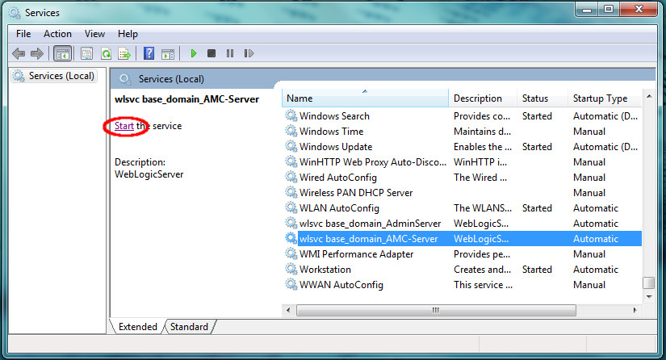

Because these services were configured with dependencies, all three services should start when the *AMC-Server* service is selected to start because of the following dependencies:

*AMC-Server*

wlsvc base_domain_AMC-Server

depends on

*Node Manager*

*Oracle Weblogic base_domain NodeManager (C_Oracle_MIDDLE~1_ORACLE~1_wlserver)*

depends on

*AdminServer*

wlsvc base_domain_AdminServer

In the case where AMC-Server is selected to start, it will wait till its dependency (Node Manager) starts. And Node Manager won’t start until its dependency (AdminServer) starts. (Likewise, if you choose to stop the “wlsvc base_domain_AdminServer” service, it works backwards, i.e. it will automatically stop the other two dependent Windows services.)

**Configure WebLogic Server with MySQL**

As taken (with some modifications) from http://docs.oracle.com/javacomponents/advanced-management-console-2/install-guide/wlssetup.htm

1. Open WebLogic Admin Console

http://*<AMC Server IP Address>:*7001/console

Username: weblogic

Password: *<Admin password>*

2. From the domain structure block to the left, go to Services and select Data Sources

3. Click "New" pull down menu, select "Generic Data Source"

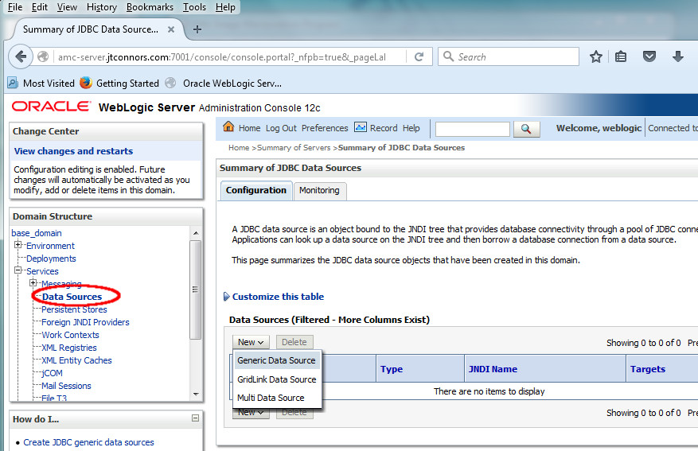

This will open up a "Create a New JDBC Data Source" page.

4. Set

Name: amc2 mysql

JNDI Name: amc2/db/mysql

Database Type: MySQL

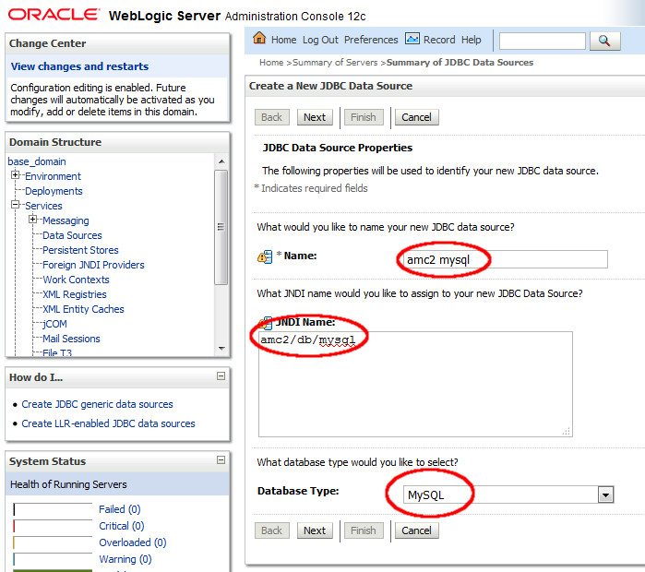

Click "Next"

5. Select "MySQL's Driver (Type4) Versions: using com.mysql.jdbc.Driver" as the Database Driver

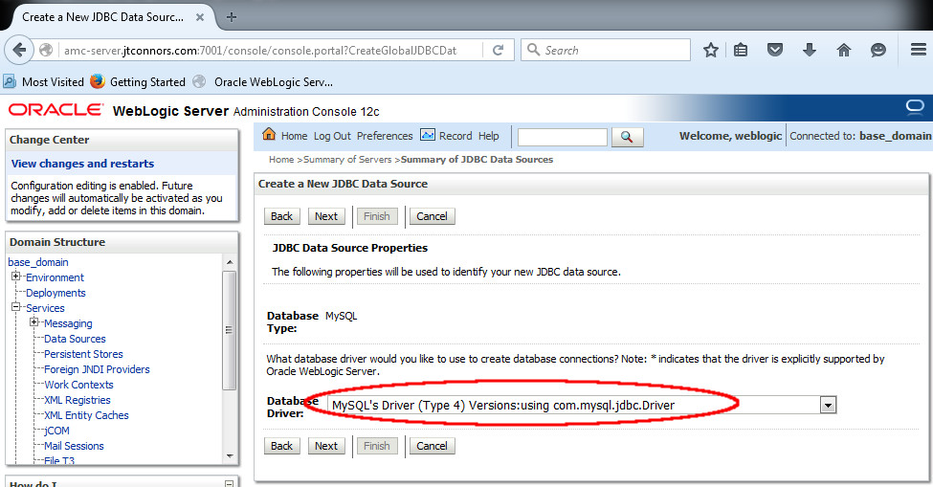

Click "Next"

6. Transactions section:

Uncheck "Supports Global Transactions" (This is checked by default)

Check "One-Phase Commit" (should be checked by default)

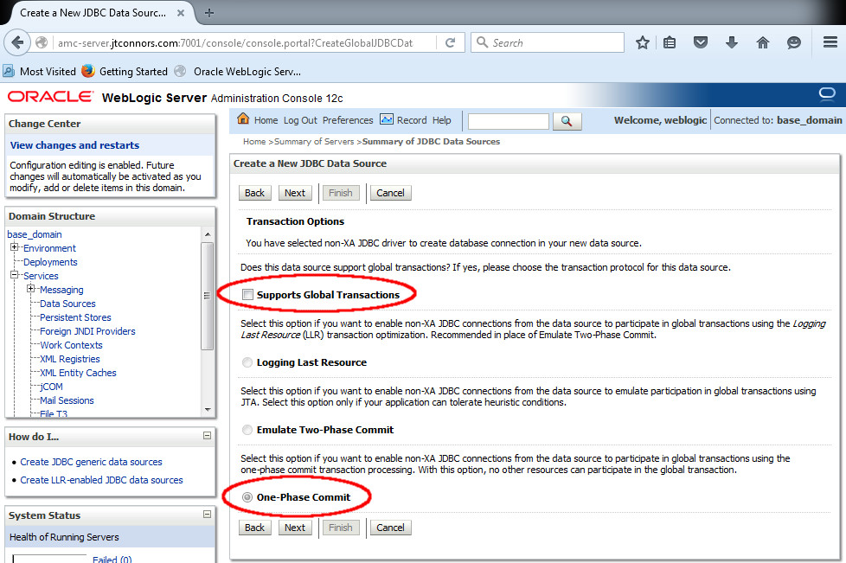

Click "Next"

7. Connection Properties, set:

Database Name: amc2

Host Name*: <AMC Server Hostname>*

Port: 3306

Database User Name: amc2

Password: amc2

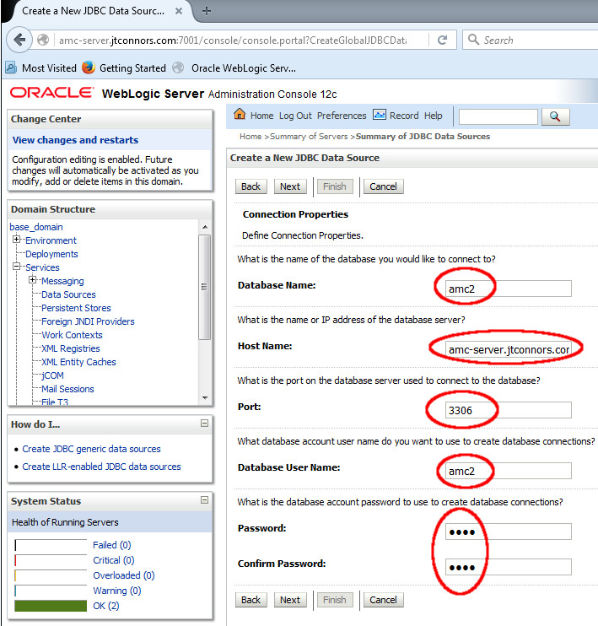

Click "Next"

8. In the Properties text box, append the following lines:

useUnicode=yes

characterEncoding=UTF-8

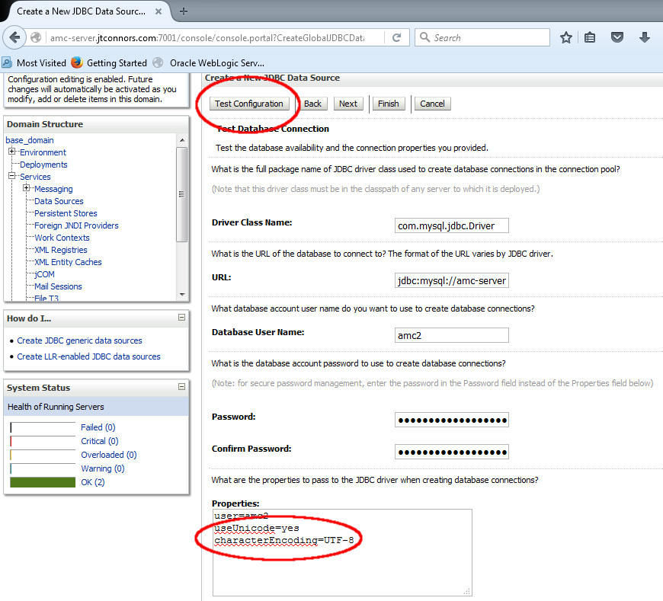

9. Click "Test Configuration"

10. Connection Test should come back as having succeeded.

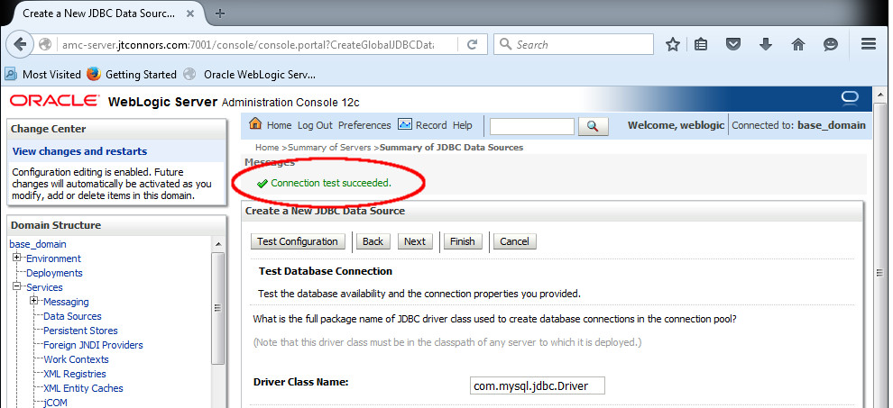

Click Next

11. The following dialog, enabling you to associate the recently created "amc2 mysql" data source with a server instance, should be displayed. Select the AMC-Server checkbox.

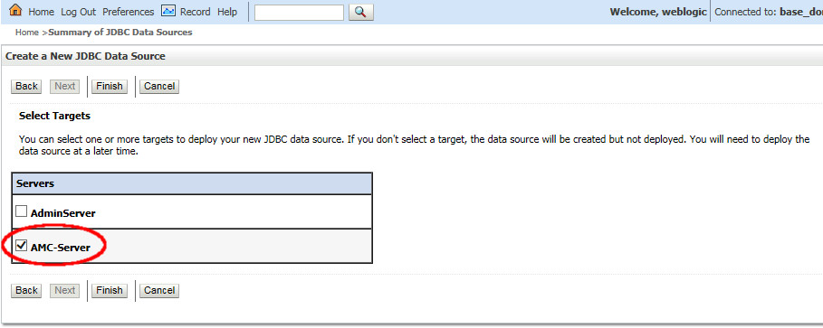

Click Finish.

12. Increase the default connection pool size for the WebLogic Server. It is recommended that the default connection pool size be set to at least 50, and under heavy loads, even higher.

Select the “amc2 mysql” data source from the JDBC Data Sources list:

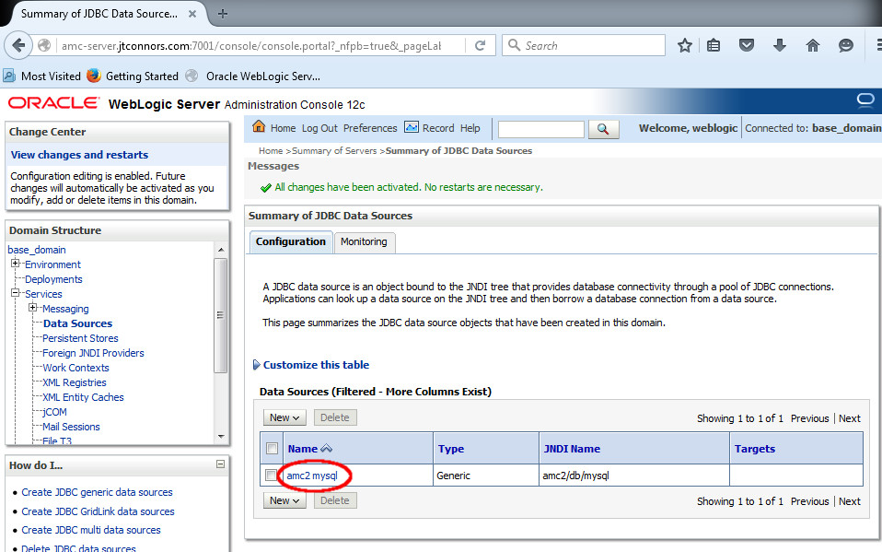

Next, select the Connection Pool tab:

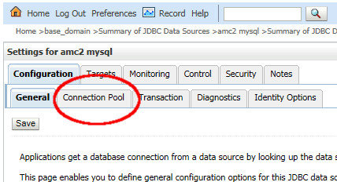

On this page, locate the “Maximum Capacity” textbox and set it to a value of 50 (or possibly larger):

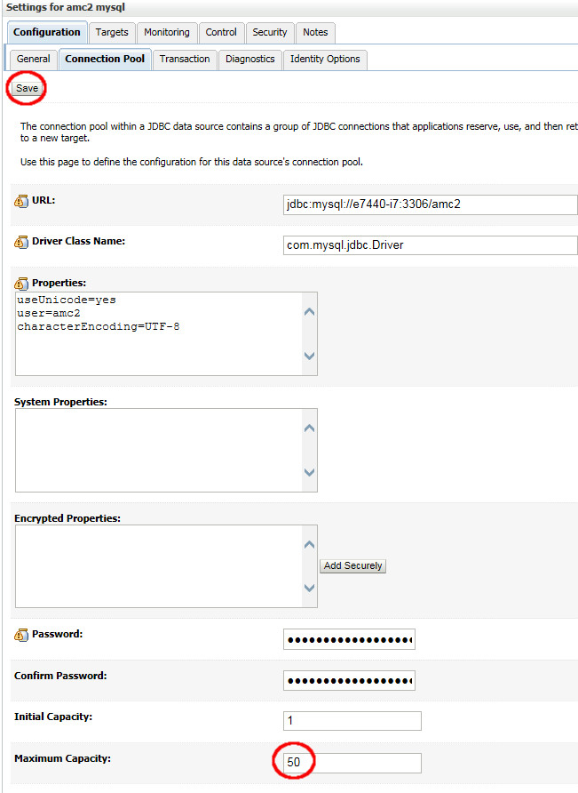

Click Save button**Deploy the Java AMC Application**

Java AMC is a Java EE application that has to be deployed into the WebLogic Server. Prior to doing so, the JAX-RS library must be deployed as a prerequisite first.

From the domain structure block to the left, go to Environment and select Deployments.

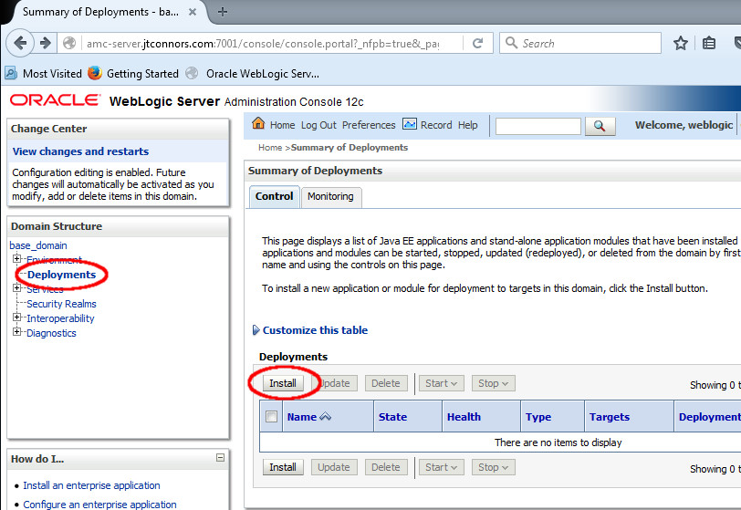

Click "Install".

Within the Install Application Assistant screen, navigate to C:\Oracle\Middleware\Oracle_Home\wlserver\common\deployable-libraries and select the jax-rs-2.0.war file.

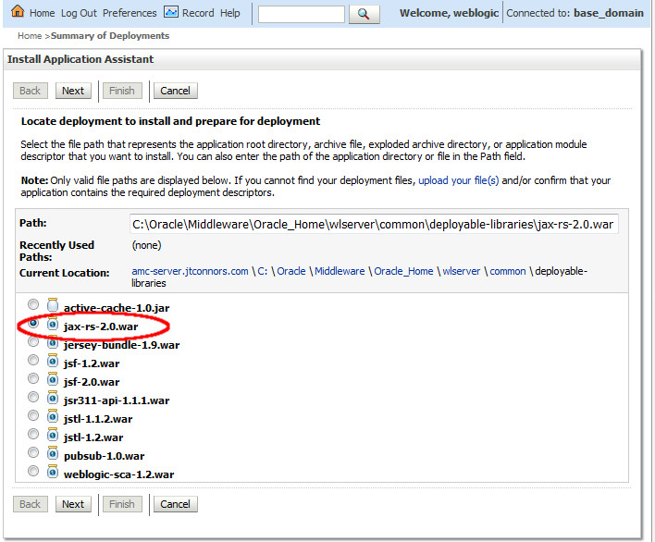

Click Next.

It should be selected already, make sure "Install this deployment as a library" is selected.

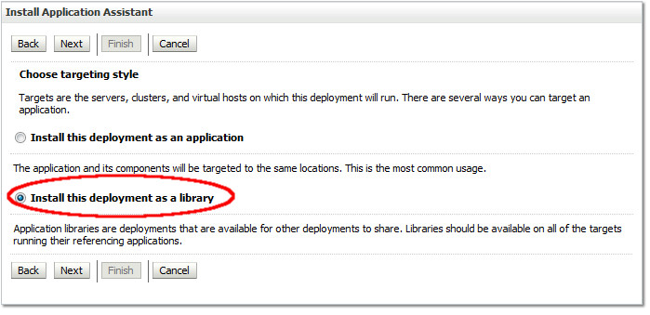

Click Next. For a target, select the AMC-Server checkbox.

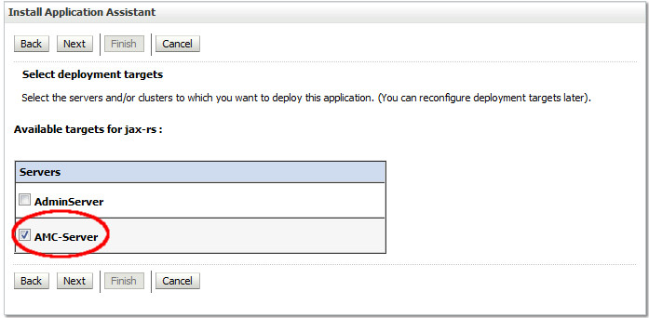

Click Next.

Leave all of the optional settings as is for the page that follows.

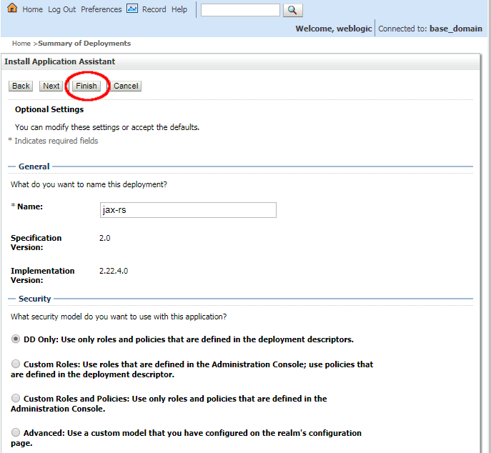

Click Finish.

Install the Java AMC application. From the Deployments page, click on Install (notice jax-rs has been installed as a library). 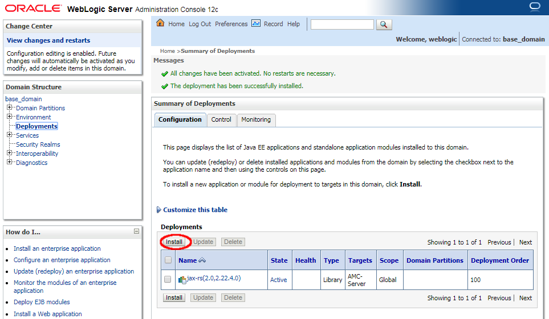

Locate where the JavaAMC-2_9.ear file was downloaded in your file system and select the file.

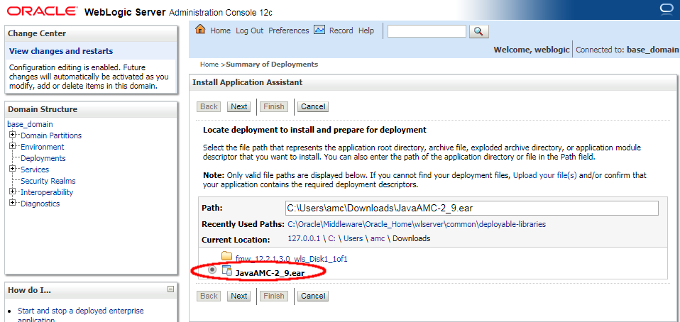

Click Next.

It should be selected already, make sure "Install this deployment as an application" is selected.

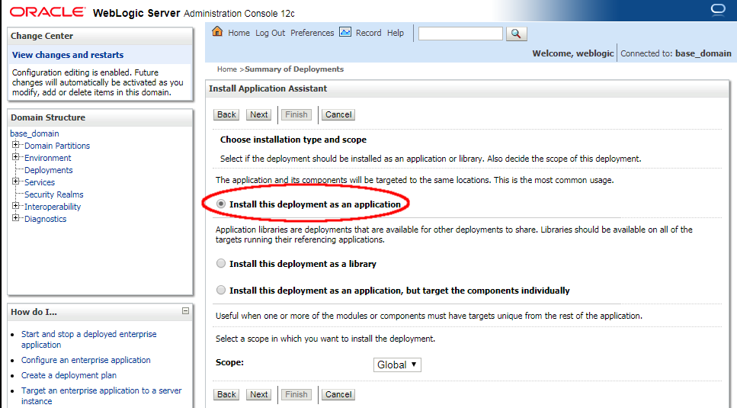

Click Next. For a target, select the AMC-Server checkbox.

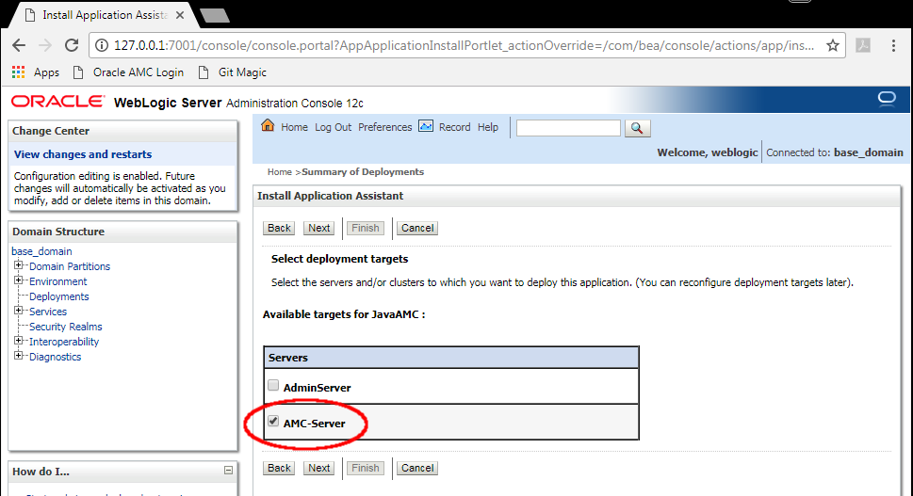

Click Next.

Leave all of the optional settings as is for the page that follows.

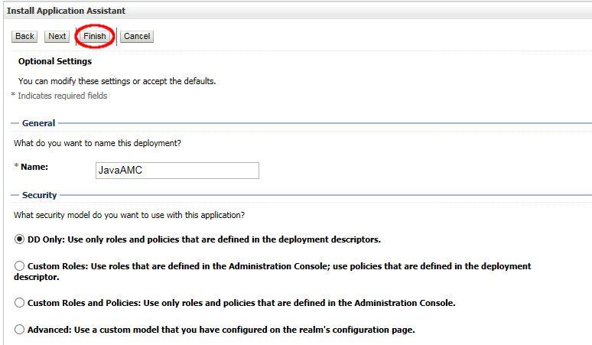

Click Finish.

Appendix

Installing MySQL 5.7.x from the ZIP Archive

The MySQL MSI installer chooses a default installation directory without giving the user an option to change it. For obvious reasons, this may not be conducive to customer conventions. The MySQL ZIP installer enables you to install MySQL manually, giving you the freedom to choose where you’d like the installation contents to reside. The example that follows installs MySQL 5.7.19 – a supported platform for Java AMC 2.9., and the latest release of MySQL as of the creation of this document

Step 1 -Download MySQL 5.7.x Community Edition for Windows 64-bit. This example uses MySQL 5.7.19 – a supported Java AMC version. MySQL 5.7.x ZIP archives can be found here:

http://dev.mysql.com/downloads/mysql/

The MySQL zip file is large and may take considerable time extracting using the standard Windows Zip utility. To speed this up considerably, prior to executing step 2 immediately below, it is recommended you download and use the 7-zip application.

Step 2 - Unzip download to the directory of your choice. In this case we’ll choose C:\Oracle

Step 3 -Create MySQL configuration file

> cd C:\Oracle\mysql-5.7.19-winx64

Depending on the version of MySQL, there may or may not be a my-default.ini file. If it exists, then follow the step below, otherwise, just create a my.ini file in the MySQL directory and simply add the contents of the next step to that file.

> copy my-default.ini my.ini

Step 4 - Configure MySQL installation to handle large BLOB entries.

Edit the recently created C:\Oracle\mysql-5.7.19-winx64\my.ini file. Append these lines. If the file already has a [mysqld] section, do not add the [mysqld] line. Just place the next two lines in the [mysqld] section. Otherwise just copy all three lines to the my.ini file.

max_allowed_packet=100M

innodb_log_file_size=768M

For MySQL 5.7 installations append these additional lines onto the my.ini file: (assuming the version of MySQL used is 5.7.19 and it is installed in C:\Oracle, your version may vary)

# set basedir to your installation path

basedir=C:\\Oracle\\mysql-5.7.19-winx64

# set datadir to the location of your data directory

datadir=C:\\Oracle\\mysql-5.7.19-winx64\\data

Step 5 - Install MySQL as a Windows service via the following command *as Administrator*:

> C:\Oracle\mysql-5.7.19-winx64\bin\mysqld.exe --install

Step 6 - Initialize MySQL

> C:\Oracle\mysql-5.7.19-winx64\bin\mysqld.exe --initialize-insecure

On next reboot, the MySQL service will start automatically. To start/stop MySQL manually, run the services.msc program from a CMD shell (as administrator), select *MySQL*, then either *Stop* or *Start*. Prior to executing step 8 below, the MySQL service must be started.

Step 7 - As a convenience, add MySQL executables to your Windows PATH.

Click on *Control Panel* ->*System* ->*Advanced System Settings* ->*Environment Variables*

Select *Path*, then the *Edit* button and click *OK* button.

Append ";C:\Oracle\mysql-5.7.19-winx64\bin\" onto the end of PATH variable

Step 8 - Create a root password for MySQL. In the example below, we set the password to 'root'. Clearly you may want to choose something more secure.

> **mysql -u root --skip-password**

mysql: [Warning] Using a password on the command line interface can be insecure.

Welcome to the MySQL monitor. Commands end with ; or \g.

Your MySQL connection id is 4

Server version: 5.7.19 MySQL Community Server (GPL)

Copyright (c) 2000, 2017, Oracle and/or its affiliates. All rights reserved.

Oracle is a registered trademark of Oracle Corporation and/or its

affiliates. Other names may be trademarks of their respective

owners.

Type 'help;' or '\h' for help. Type '\c' to clear the current input statement.

mysql> **ALTER USER 'root'@'localhost' IDENTIFIED BY 'root';**

Query OK, 0 rows affected (0.00 sec)

mysql> **exit**

Bye

Step 9 - Create amc2 user. This is specific to MySQL and is not another Windows user. This information is taken from *Configuring MySQL* (<http://docs.oracle.com/javacomponents/advanced-management-console-2/install-guide/dbsetup.htm#CHDDCEBF>with some fixes/modifications).

> **mysql -u root -p**

Enter password: ****

Welcome to the MySQL monitor. Commands end with ; or \g.

Your MySQL connection id is 5

Server version: 5.7.19 MySQL Community Server (GPL)

Copyright (c) 2000, 2017, Oracle and/or its affiliates. All rights reserved.

Oracle is a registered trademark of Oracle Corporation and/or its

affiliates. Other names may be trademarks of their respective

owners.

Type 'help;' or '\h' for help. Type '\c' to clear the current input statement.

mysql> **create user 'amc2' identified by 'amc2';**

Query OK, 0 rows affected (0.00 sec)

Create the database and grant all access to the amc2 user

mysql> **create database amc2;**

Query OK, 1 row affected (0.00 sec)

mysql> **grant all on amc2.* to 'amc2';**

Query OK, 0 rows affected (0.00 sec)

mysql> **exit**

Bye

**Manually Installing Windows Services for WebLogic, Node Manager, and the Java AMC Server Application**

The following manual steps will create three Windows services that will enable WebLogic, the WebLogic Node Manager and the Java AMC application to automatically start up at boot time.

(Reference: http://docs.oracle.com/middleware/1213/wls/WLJCA/START/winservice.htm)

1. Create a scripts directory. It can be located anywhere, preferably away from the WebLogic installation, so that it might be saved across installations.

>mkdir scripts

>cd scripts

2. Create a file called svcsetup.cmd in the scripts/ directory that will contain the pertinent Windows environment variables associated with this WebLogic installation. It should look as follows:

REM AMC Master Directory

set AMC_HOME=C:\Oracle

REM All subsequent variables are set relative to AMC_HOME

set JAVA_HOME=%AMC_HOME%\jdk8

set MW_HOME=%AMC_HOME%\Middleware\Oracle_Home

set DOMAIN_NAME=base_domain

set DOMAIN_HOME=%MW_HOME%\user_projects\domains\%DOMAIN_NAME%

set USERDOMAIN_HOME=%DOMAIN_HOME%

3. In order to have subsequent WebLogic-dependent Windows services (which we'll set up in the next few steps) start after the initial WebLogic service completes, we'll need to modify the WebLogic server InstallSvc.cmd script.

a. Make a copy of %MW_HOME%\wlserver\server\bin\installSvc.cmd so we can revert back to the original if need be.

>svcsetup.cmd

>cd %MW_HOME%\wlserver\server\bin

>copy installSvc.cmd installWebLogicSvc.cmd

b. Edit the newly createdinstallWebLogicSvc.cmd. At the end of the file, you'll find lines which look something like:

rem *** Install the service "%WL_HOME%\server\bin\%WLSVC_EXE_TO_USE%" -install ...

Right after the -svcname:"wlsvc %DOMAIN_NAME%_%SERVER_NAME%" argument, insert the following additional argument:

-delay:15000

This specifies the number of milliseconds to wait before the Microsoft Management Console changes the service status from SERVER_START_PENDING to STARTED. This gives the WebLogic service time to start up, and makes dependent services wait for the specified number of milliseconds before they can start.

4. In the scripts/ directory, create a wrapper file called installWebLogicSvc.cmd. It has the same name as the file in the previous step (and will call that script) but is located in a different directory. It should look as follows:

@echo off

SETLOCAL

call svcsetup.cmd

set MAX_CONNECT_RETRIES=4

call "%USERDOMAIN_HOME%\bin\setDomainEnv.cmd"

call "%MW_HOME%\wlserver\server\bin\installWebLogicSvc.cmd"

ENDLOCAL

5**. As administrator**, make sure you are in the scripts directory and run installWebLogicSvc.cmd from a CMD terminal.

>cd scripts

>installWebLogicSvc.cmd

This should result in the creation of a service called *wlsvc base_domain_AdminServer*.

You can confirm its existence by starting the Windows Services utility, services.msc, from a CMD terminal as Administrator. Once located, you can start the service (and wait 15 seconds for completion).

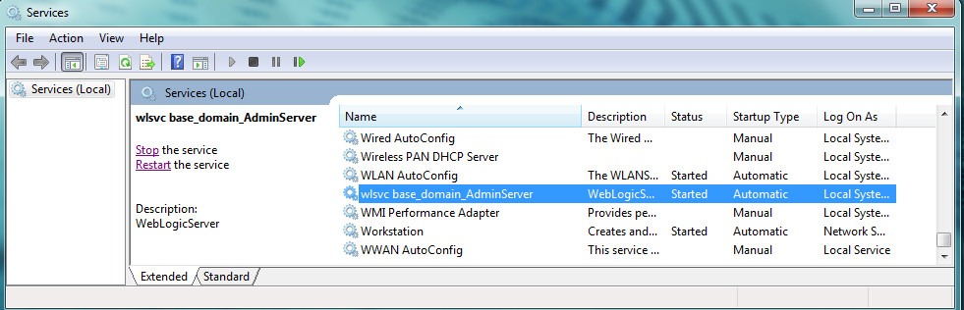

6. In order to make our next Windows service (NodeManager service) start after the initial WebLogic service completes, we'll need to modify the WebLogic serverInstallNodeMgrSvc.cmd script.

a. Make a copy of %MW_HOME%\wlserver\server\bin\installNodeMgrSvc.cmd so we can revert back to the original if need be.

>svcsetup.cmd

>cd %MW_HOME%\wlserver\server\bin

>copy installNodeMgrSvc.cmd installNodeMgrSvc_ORIG.cmd

b. Edit %MW_HOME%\wlserver\server\bin\installNodeMgrSvc.cmd. At the end of the file, you'll find lines which look something like:

rem *** Install the service

"%WL_HOME%\server\bin\%WLSVC_EXE_TO_USE%" -install ...

Right after the -svcname:"%PROD_NAME% NodeManager (%BAR_WL_HOME%)" argument, insert the following additional argument:

-depend:"wlsvc base_domain_AdminServer"

With this option, the Microsoft Management Console will wait for the AdminServer Windows service to report a status of STARTED before it starts the NodeManager Windows service.

7 .In the scripts/ directory, create a wrapper file called installNodeMgrSvc.cmd. It has the same name as the file in the previous step (and will call that script) but is located in a different directory. It should look as follows:

@echo off

SETLOCAL

call svcsetup.cmd

call "%USERDOMAIN_HOME%\bin\setDomainEnv.cmd"

call "%USERDOMAIN_HOME%\bin\installNodeMgrSvc.cmd"

ENDLOCAL

8. **As administrator**, make sure you are in the scripts/ directory and run installNodeMgrSvc.cmd from a CMD terminal

>cd scripts

>installNodeMgrSvc.cmd

This should result in a service called:

*Oracle Weblogic base_domain NodeManager (C_Oracle_MIDDLE~1_ORACLE~1_wlserver)*

You can confirm its existence by starting the Windows Services utility, services.msc, from a CMD terminal as Administrator. Once located, you can start the service.

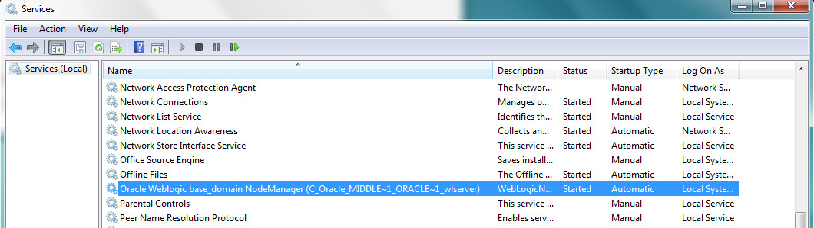

9. In order to make our final Windows service (AMC-Server service) also start after the initial WebLogic service completes, we'll need to copy and modify the WebLogic server InstallSvc.cmd script.

a. Make a copy of %MW_HOME%\wlserver\server\bin\installSvc.cmd so we can revert back to the original if need be.

>svcsetup.cmd

>cd %MW_HOME%\wlserver\server\bin

>copy installSvc.cmd installAMCServerSvc.cmd

b. Edit %MW_HOME%\wlserver\server\bin\installAMCServerSvc.cmd. At the end of the file, you'll find lines which look something like:

rem *** Install the service

"%WL_HOME%\server\bin\%WLSVC_EXE_TO_USE%" -install ...

Right after the -svcname:"wlsvc %DOMAIN_NAME%_%SERVER_NAME%" argument, insert the following additional argument:

-depend:"wlsvc base_domain_AdminServer","Oracle Weblogic base_domain NodeManager (C_Oracle_MIDDLE~1_ORACLE~1_wlserver)"

With this option, the Microsoft Management Console will wait for the AdminServer Windows service to report a status of STARTED before it starts the *AMC-Server* Windows service.

10. In the scripts/ directory, create a wrapper file called installAMCServerSvc.cmd. It has the same name as the file in the previous step (and will call that script) but is located in a different directory. It should look as follows and be edited accordingly:

@echo off

SETLOCAL

call svcsetup.cmd

set SERVER_NAME=AMC-Server

set WLS_USER=***<weblogic user name - typically weblogic>***

set WLS_PW*=****<weblogic user password>***

set ADMIN_URL=http://**<*your admin server IP address*>**:7001

set USER_MEM_ARGS=-Xmx4096m

cd %DOMAIN_HOME%

call "%MW_HOME%\wlserver\server\bin\installAMCServerSvc.cmd"

ENDLOCAL

11. If left alone, the AMC-Server Java process will start up with a small maximum heap size of 200MB, causing the AMC-Server to run out of memory. If you see OutOfMemoryError messages in the AMC-Server log files, this may be the culprit. The step to correct this situation was done in the previous step where the installAMCServerSvc.cmd file includes the following line:

set USER_MEM_ARGS=-Xmx4096m

12. **As administrator**, make sure you are in the scripts/ directory and run installAMCServerSvc.cmd from a CMD terminal

>cd scripts

>installAMCServerSvc.cmd

This should result in a service called: *wlsvc base_domain_AdminServer*

You can confirm its existence starting the Windows Services utility, services.msc, from a CMD terminal as Administrator. Once located, you can start the service.

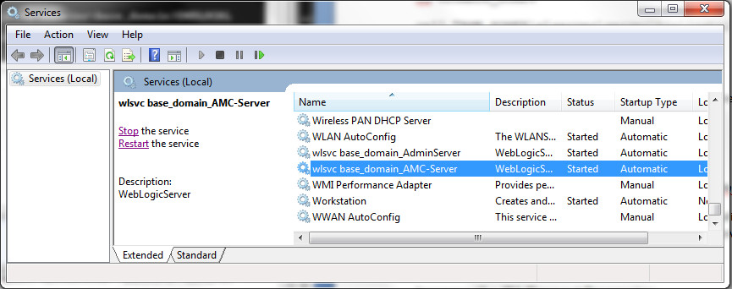

13. Optional: If the need arises, you can create and utilize the following scripts to uninstall the Java AMC WebLogic services created above.

a. In the scripts/ directory create a file called uninstallAMCServerSvc.cmd. It should look as follows:

@echo off

SETLOCAL

call svcsetup.cmd

set SERVER_NAME=AMC-Server

cd %DOMAIN_HOME%

call "%MW_HOME%\wlserver\server\bin\uninstallSvc.cmd"

ENDLOCAL

b. In the same scripts/ directory create a file called uninstallNodeMgrSvc.cmd. It should look as follows:

@echo off

SETLOCAL

call svcsetup.cmd

call "%USERDOMAIN_HOME%\bin\setDomainEnv.cmd"

call "%USERDOMAIN_HOME%\bin\uninstallNodeMgrSvc.cmd"

ENDLOCAL

c. In the same scripts/ directory create a file called uninstallWebLogicSvc.cmd. It should look as follows:

@echo off

SETLOCAL

call svcsetup.cmd

set SERVER_NAME=AdminServer

cd %DOMAIN_HOME%

call "%MW_HOME%\wlserver\server\bin\uninstallSvc.cmd"

ENDLOCAL

**As Administrator**, you can run these scripts to uninstall the WebLogic Services associate with Java AMC.

**Revision History**

**Version 2.9, Rev 0: AMC-InstallGuide-Win-MySQL: 28-Mar-2018**

* First version to be brought into GIT repository
* Update Install to Java AMC 2.9
* Update Install to WebLogic 12.2.1.3
* Reworked WebLogic 12.2.1.3 Install screenshots
* Reworked WebLogic Configuration Manager screenshots for version 12.2.1.3
* Reworked *Install Windows Services* section
* Reworked *Deploy The Java AMC Application* section screenshots
* Leave MySQL install alone, however mention latest supported MySQL version is now 5.7.21
* Comment on bug and workaround concerning WebLogic 12.2.1.3 installation with jdk8u161/162
* Added footer with page number and revision

**Rev 0: AMC_2_7-InstallGuide-Win-MySQL: 24-Jul_2017**

* Update Install to Java AMC 2.7
* Update latest Java 8 baseline to JDK 8 update 141
* Reference to latest MySQL (5.7.19), but still show 5.7.13 example install
* Update MySQL Zip archive install section to use MySQL 5.7.19
* Update install to WebLogic 12.2.1.2
* Added Install Windows Services Section (automated by scripts)
* Move manual Install Windows Services Section to Appendix
* Manual Windows Service Install: Added dependency to NodeManager in AMC-Server service

**Rev 0: AMC_2_6-InstallGuide: 27-Jan_2017**

* Support for AMC 2.6
* Update latest Java 8 baseline to JDK 8 update 121
* Added part to increase JDBC connection pool maximum

**Rev 0: AMC_2_5-InstallGuide: 28-Oct_2016**

* Support for AMC 2.5
* Update latest Java 8 baseline to JDK 8 update 111
* Update reference to latest MySQL 5.7.16, but kept 5.7.13 install screenshots
* Changes to manual MySQL installation, add basedir and datadir to my.ini file.
* Update reference to latest WebLogic 12.2.1.2, but kept 12.2.1 install screenshots

**Rev 0: AMC_2_4-InstallGuide: 26-July_2016**

* Support for AMC 2.4
* Change to MySQL 5.7.x (5.7.13)

### Update latest Java 8 baseline to JDK 8 update 101

### Change to WebLogic 12.2

### DRS tool gone, eliminate DRS tool self-signing documentation.

### Rev. 4: 29-Apr-2016

### Added appendix to install MySQL 5.6.30 manually

### Reorder sections: place *Additional WebLogic Configuration...* before *Install Windows Services...*

### In *Install Windows Services...* section, increase AMC-Server heap size to -Xmx2048m

### In *Install an Identity Certificate...* section, start WebLogic server if not already started

### Updated the *Deploy Java AMC Application* section to Java AMC 2.3

### Update latest Java 8 baseline to JDK 8 update 91

### Rev. 5: 19-May-2016

### In *Install Windows Services...* section, increase AMC-Server heap size to –Xmx4096m

### No longer need to modify CommEnv.cmd to increase AMC-Server heap to -Xmx4906m, just set USER_MEM_ARGS in the scripts/installAMCServerSvc.cmd file

### fix typo in scripts/installWebLogicSvc.cmd

### Updated Windows Services scripts, added uninstall service scripts to this section